PumasCP Validation Reports
Sponsor: Sponsor Name

Author Name¹ and Author Name¹
¹Organization Name

February 1, 2026

Contents

List of Figures

List of Tables

Task: NCA + BE

Input plots
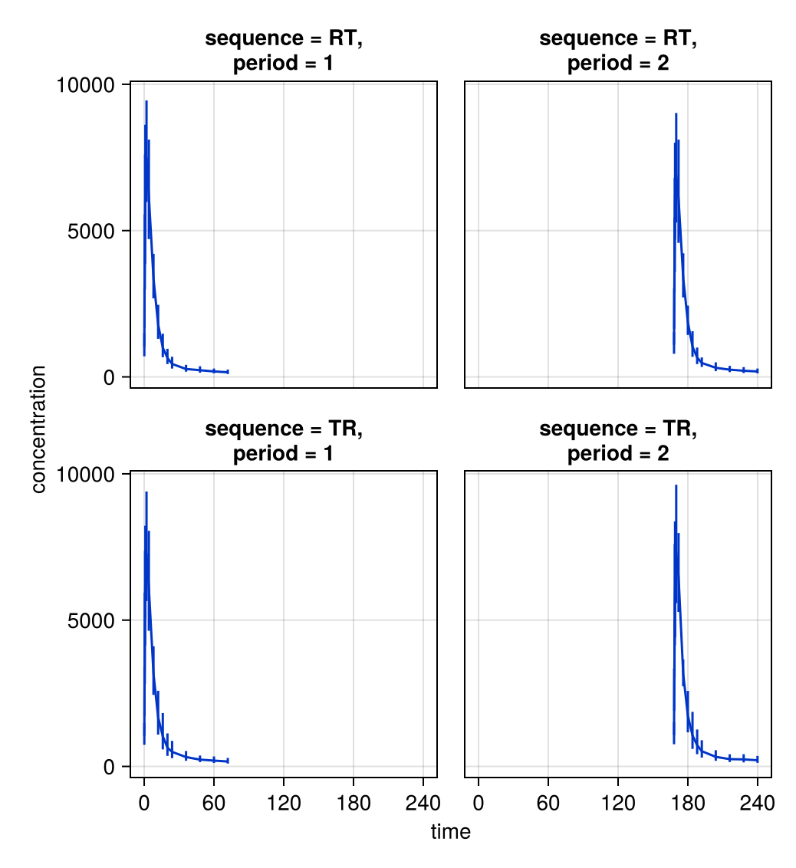
Summary Observations vs. Time

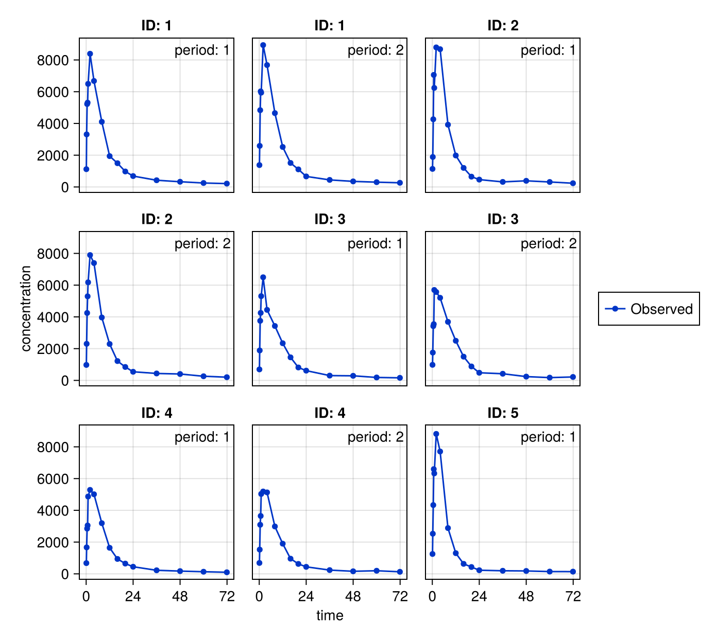
Observations vs. Time (1 of 5)

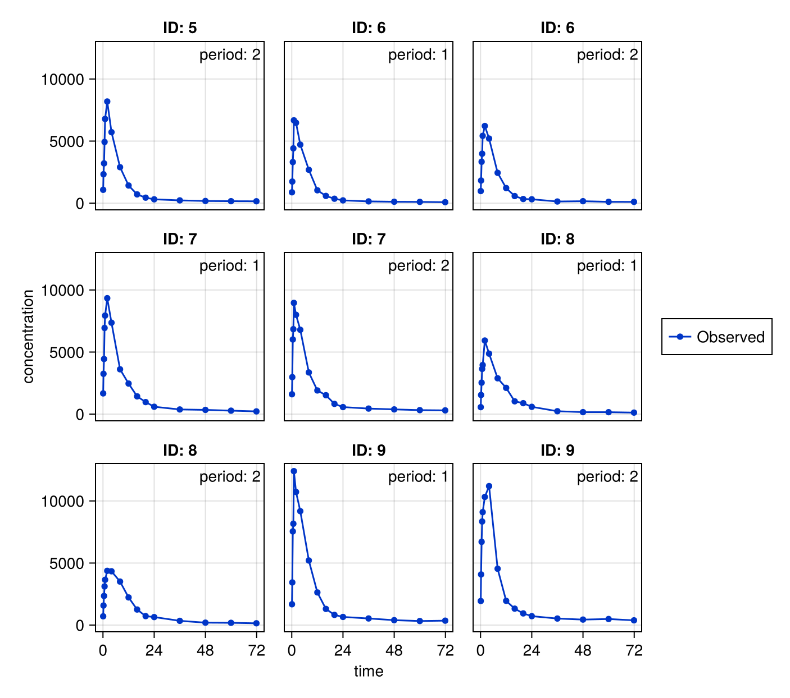
Observations vs. Time (2 of 5)

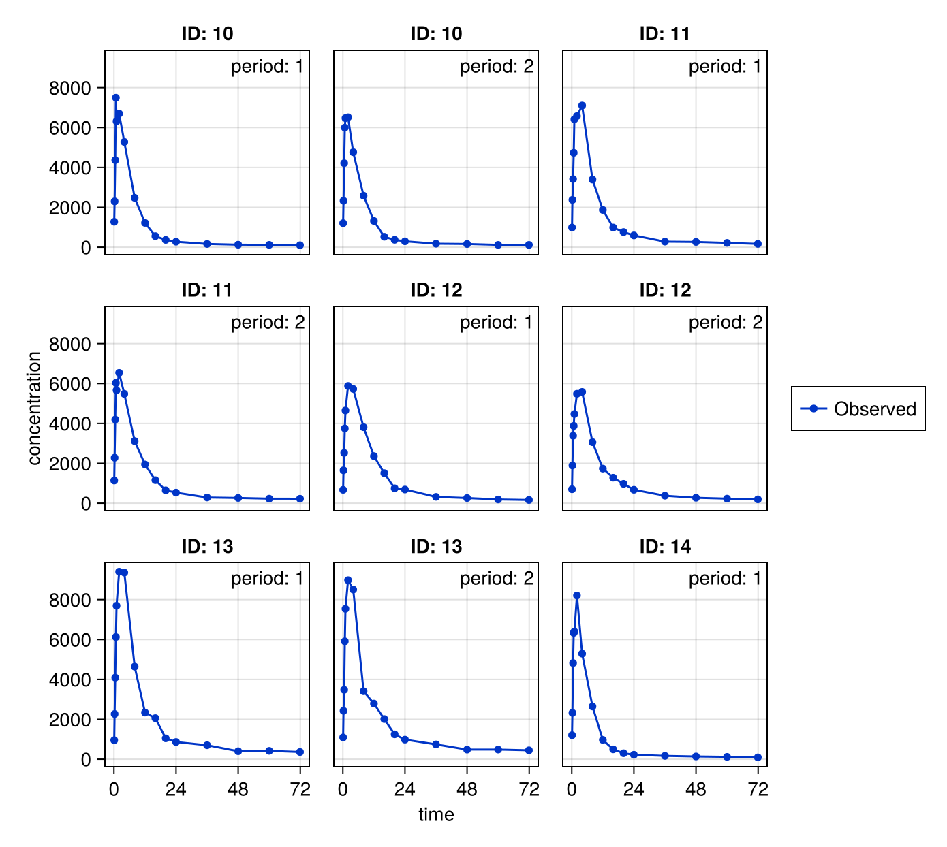
Observations vs. Time (3 of 5)

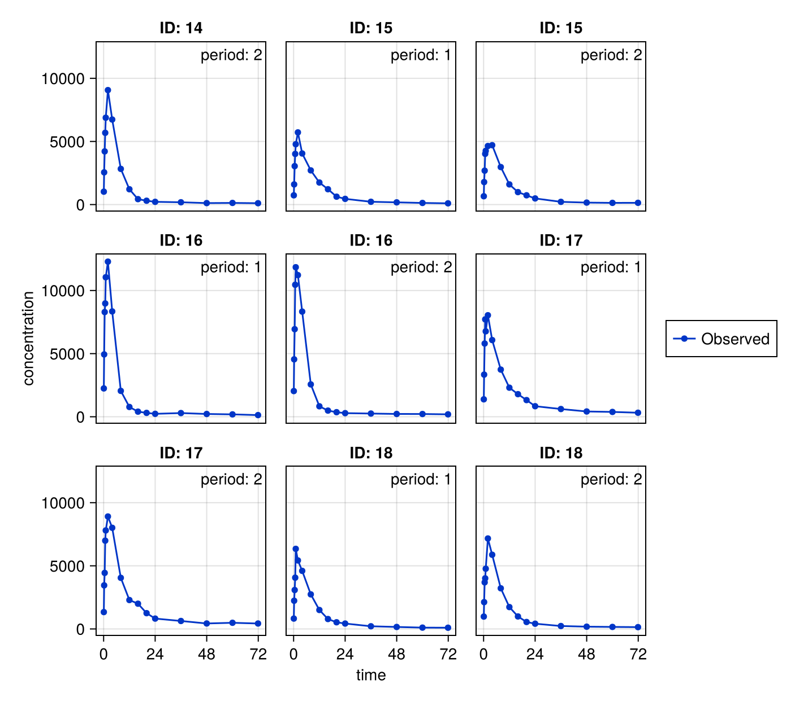
Observations vs. Time (4 of 5)

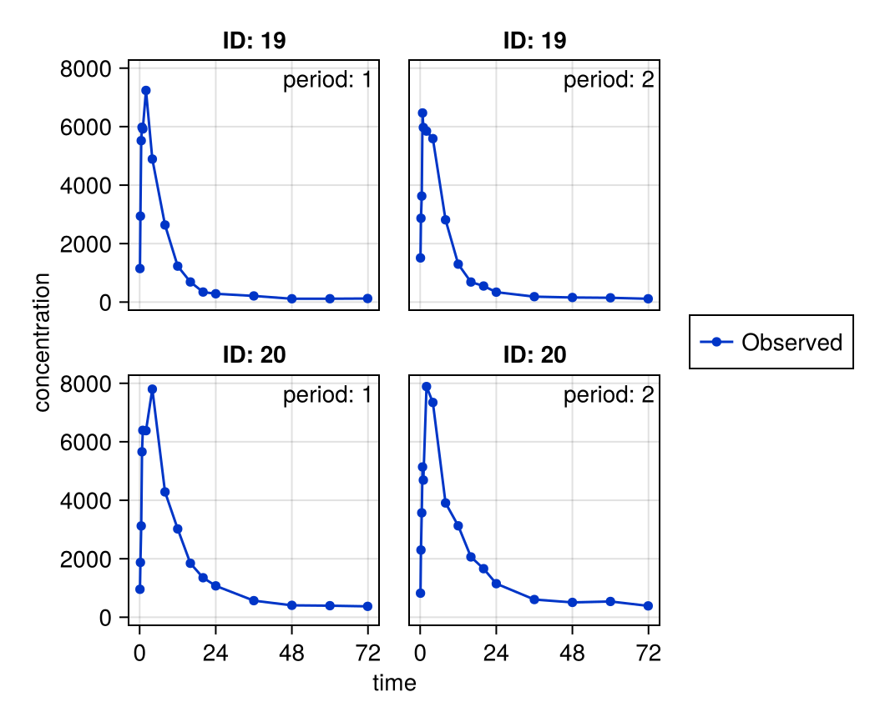
Observations vs. Time (5 of 5)

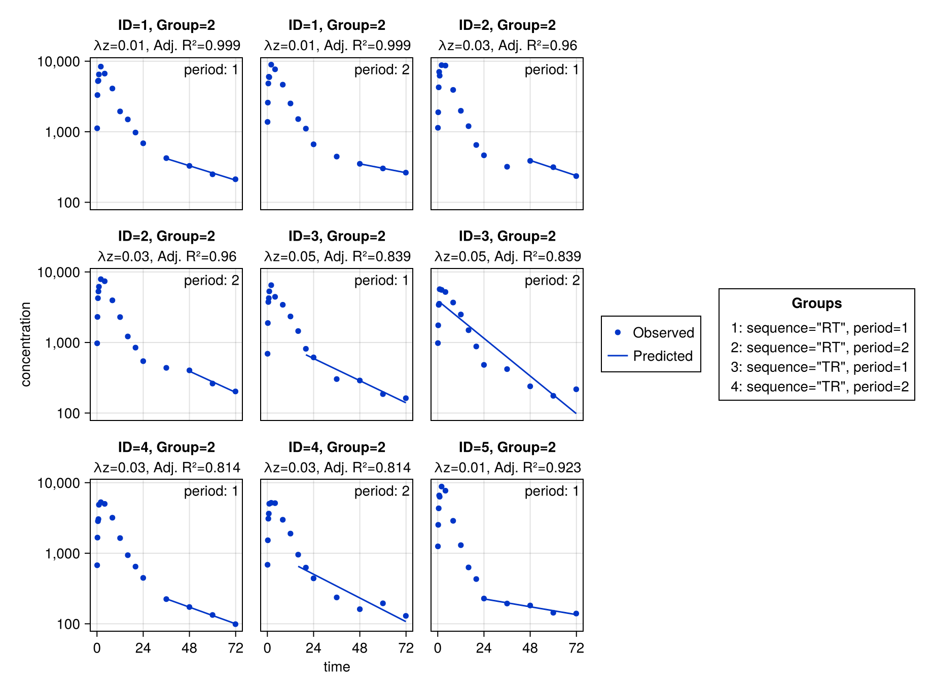
Subject Fits (1 of 5)

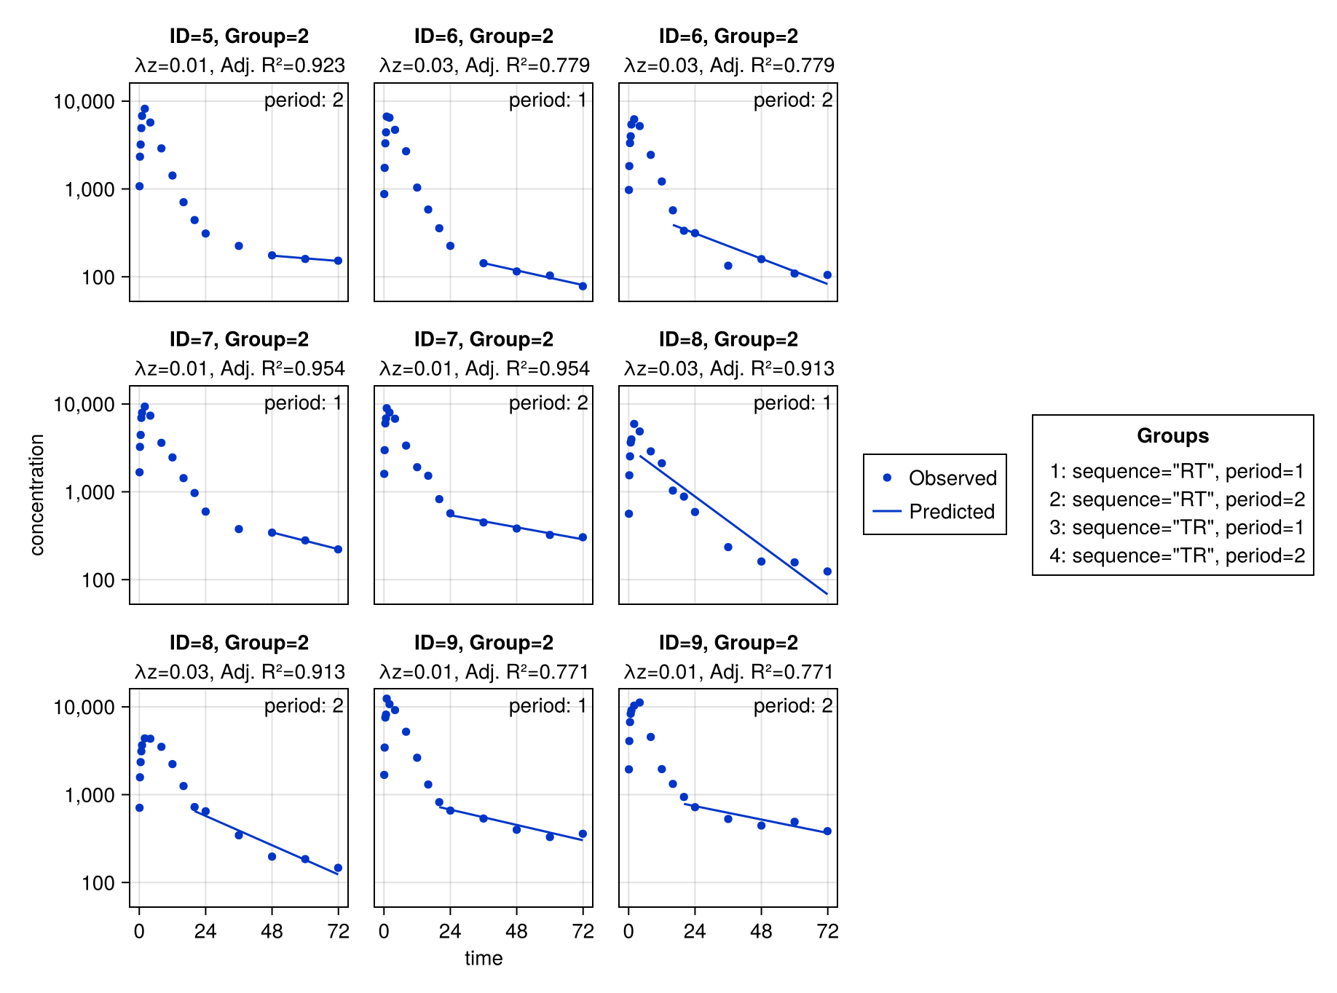
Subject Fits (2 of 5)

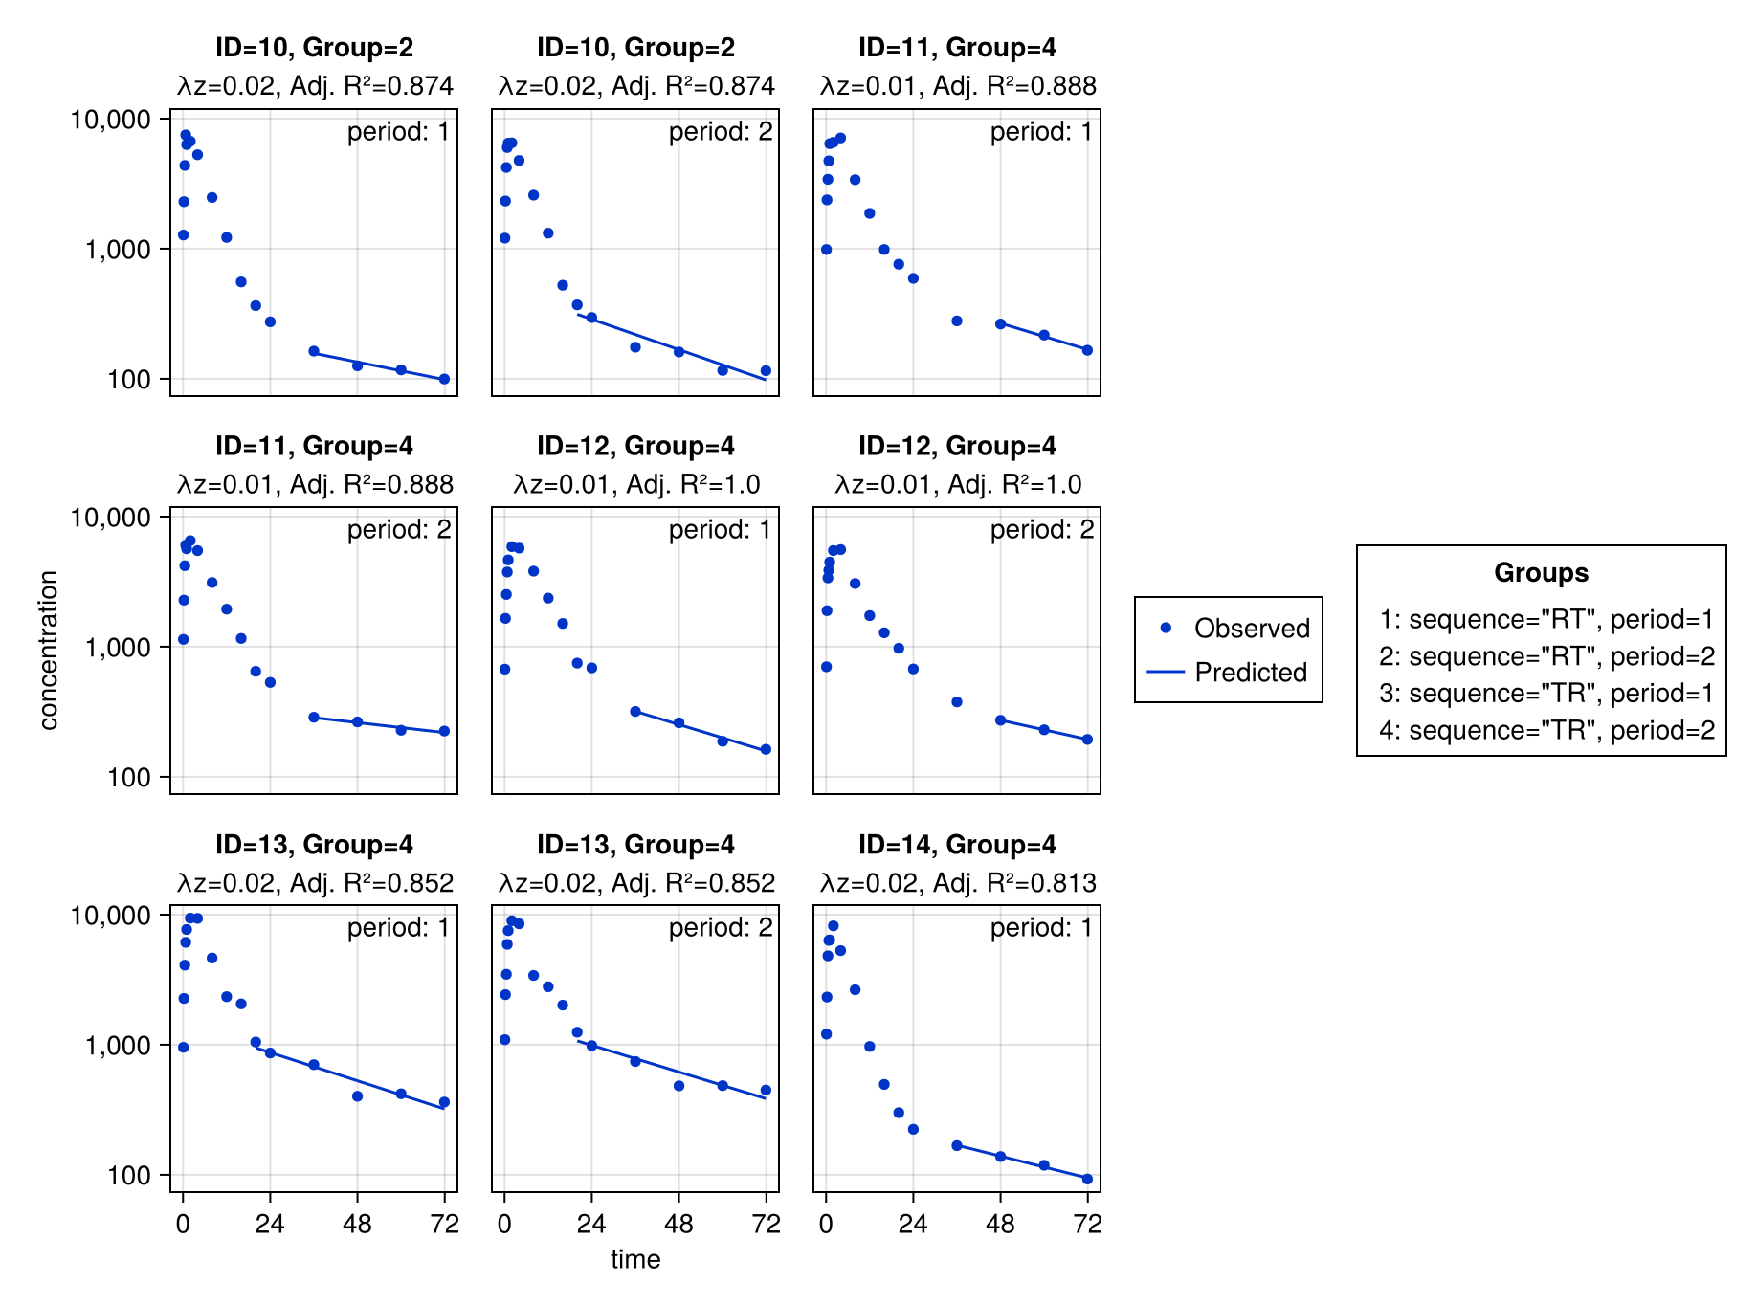
Subject Fits (3 of 5)

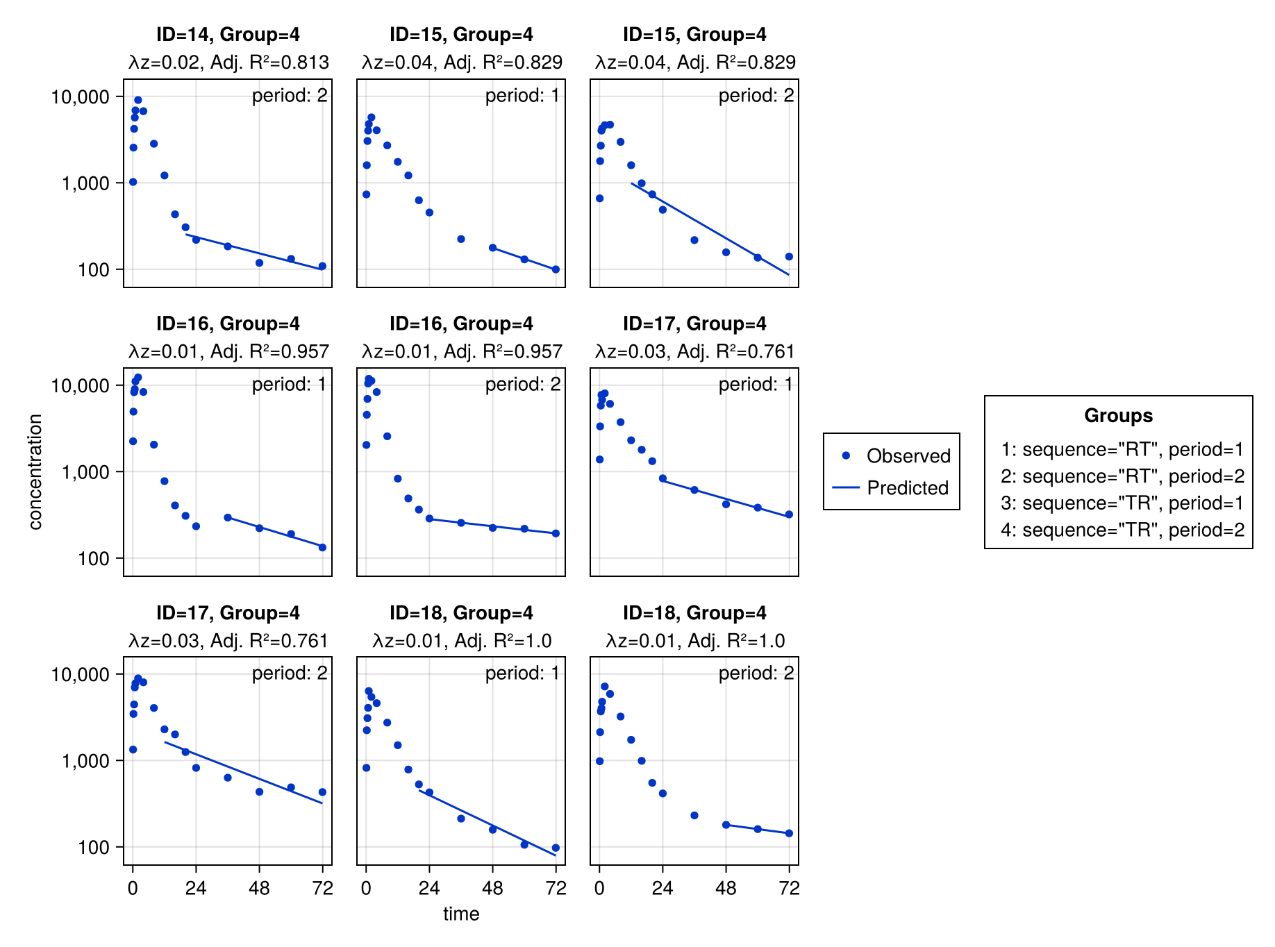
Subject Fits (4 of 5)

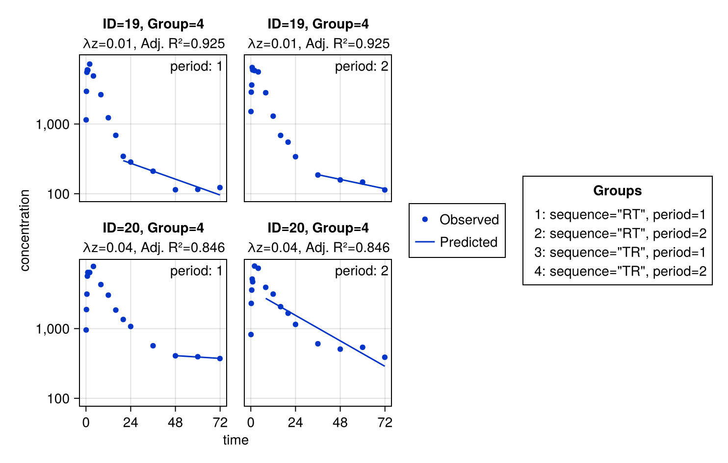
Subject Fits (5 of 5)

Input tables
Listing of concentrations at nominal time points
 |  |  | time
 |  |  | 0 | 0.1 | 0.25 | 0.5 | 0.75 | 1 | 2 | 4 | 8 | 12 | 16 | 20 | 24 | 36 | 48 | 60 | 71.9 | 168 | 168 | 168 | 168 | 169 | 169 | 170 | 172 | 176 | 180 | 184 | 188 | 192 | 204 | 216 | 228 | 240
sequence | period | id | concentration
RT | 1 | 1 | - | 1120 | 3312 | 5224 | 5309 | 6493 | 8390 | 6676 | 4103 | 1942 | 1496 | 976 | 686 | 423 | 328 | 250 | 212
RT | 1 | 2 | - | 1138 | 1889 | 4263 | 7059 | 6238 | 8790 | 8678 | 3922 | 1983 | 1200 | 650 | 464 | 319 | 387 | 315 | 235
RT | 1 | 3 | - | 693 | 1887 | 3754 | 4252 | 5306 | 6495 | 4443 | 3427 | 2340 | 1453 | 815 | 615 | 303 | 289 | 186 | 162
RT | 1 | 4 | - | 676 | 1667 | 2850 | 3047 | 4870 | 5288 | 5013 | 3190 | 1640 | 939 | 647 | 448 | 224 | 173 | 133 | 98.8
RT | 1 | 5 | - | 1252 | 2528 | 4332 | 6595 | 6326 | 8814 | 7705 | 2883 | 1302 | 630 | 431 | 228 | 194 | 182 | 143 | 140
RT | 1 | 6 | - | 875 | 1739 | 3309 | 4414 | 6672 | 6472 | 4712 | 2688 | 1037 | 583 | 357 | 225 | 143 | 115 | 103 | 78.1
RT | 1 | 7 | - | 1669 | 3248 | 4442 | 6940 | 7937 | 9337 | 7362 | 3611 | 2463 | 1432 | 969 | 596 | 377 | 343 | 280 | 221
RT | 1 | 8 | - | 562 | 1543 | 2534 | 3642 | 3953 | 5928 | 4870 | 2888 | 2115 | 1033 | 882 | 589 | 235 | 161 | 157 | 124
RT | 1 | 9 | - | 1679 | 3436 | 7546 | 8161 | 12401 | 10723 | 9176 | 5204 | 2632 | 1305 | 822 | 659 | 535 | 398 | 329 | 359
RT | 1 | 10 | - | 1275 | 2299 | 4364 | 7495 | 6313 | 6696 | 5277 | 2476 | 1221 | 555 | 365 | 274 | 163 | 126 | 117 | 99.7
 |  | N | 0 | 10 | 10 | 10 | 10 | 10 | 10 | 10 | 10 | 10 | 10 | 10 | 10 | 10 | 10 | 10 | 10
 |  | GeoMean | - | 1028 | 2257 | 4076 | 5419 | 6361 | 7515 | 6180 | 3360 | 1788 | 996 | 649 | 442 | 269 | 227 | 186 | 156
 |  | GeoCV% | - | 39.4 | 31.2 | 31.7 | 34.9 | 31 | 23.2 | 27.7 | 22.7 | 32.8 | 40.9 | 40.8 | 46.4 | 44.8 | 50.1 | 44.4 | 50.3
 |  | Minimum | - | 562 | 1543 | 2534 | 3047 | 3953 | 5288 | 4443 | 2476 | 1037 | 555 | 357 | 225 | 143 | 115 | 103 | 78.1
 |  | Maximum | - | 1679 | 3436 | 7546 | 8161 | 12401 | 10723 | 9176 | 5204 | 2632 | 1496 | 976 | 686 | 535 | 398 | 329 | 359
TR | 1 | 11 | - | 986 | 2373 | 3415 | 4733 | 6412 | 6573 | 7103 | 3391 | 1868 | 986 | 759 | 591 | 279 | 264 | 217 | 166
TR | 1 | 12 | - | 672 | 1651 | 2522 | 3749 | 4649 | 5877 | 5726 | 3809 | 2362 | 1508 | 748 | 687 | 318 | 260 | 187 | 163
TR | 1 | 13 | - | 955 | 2269 | 4091 | 6127 | 7693 | 9401 | 9358 | 4643 | 2341 | 2061 | 1049 | 864 | 703 | 402 | 420 | 362
TR | 1 | 14 | - | 1206 | 2325 | 4824 | 6335 | 6398 | 8203 | 5292 | 2645 | 969 | 495 | 300 | 224 | 168 | 138 | 118 | 92.7
TR | 1 | 15 | - | 734 | 1598 | 3046 | 4013 | 4782 | 5719 | 4048 | 2709 | 1748 | 1216 | 628 | 453 | 223 | 177 | 130 | 99.7
TR | 1 | 16 | - | 2245 | 4939 | 8293 | 8976 | 11051 | 12288 | 8345 | 2050 | 776 | 406 | 308 | 233 | 294 | 221 | 190 | 133
TR | 1 | 17 | - | 1382 | 3339 | 5802 | 7716 | 6768 | 8042 | 6077 | 3737 | 2304 | 1791 | 1321 | 837 | 613 | 419 | 383 | 320
TR | 1 | 18 | - | 821 | 2236 | 3084 | 4062 | 6346 | 5426 | 4600 | 2739 | 1501 | 785 | 528 | 427 | 212 | 158 | 106 | 97.5
TR | 1 | 19 | - | 1147 | 2940 | 5521 | 5979 | 5921 | 7239 | 4890 | 2637 | 1229 | 688 | 344 | 284 | 210 | 114 | 115 | 122
TR | 1 | 20 | - | 955 | 1874 | 3122 | 5658 | 6392 | 6380 | 7800 | 4285 | 3020 | 1845 | 1351 | 1073 | 567 | 407 | 395 | 372
 |  | N | 0 | 10 | 10 | 10 | 10 | 10 | 10 | 10 | 10 | 10 | 10 | 10 | 10 | 10 | 10 | 10 | 10
 |  | GeoMean | - | 1046 | 2414 | 4095 | 5521 | 6457 | 7287 | 6110 | 3168 | 1675 | 1030 | 638 | 496 | 318 | 232 | 198 | 167
 |  | GeoCV% | - | 35.9 | 35.1 | 38.5 | 29.6 | 24.6 | 25.8 | 28.1 | 26.4 | 45.5 | 62.1 | 61.8 | 61.1 | 53.8 | 49.8 | 58.1 | 59.3
 |  | Minimum | - | 672 | 1598 | 2522 | 3749 | 4649 | 5426 | 4048 | 2050 | 776 | 406 | 300 | 224 | 168 | 114 | 106 | 92.7
 |  | Maximum | - | 2245 | 4939 | 8293 | 8976 | 11051 | 12288 | 9358 | 4643 | 3020 | 2061 | 1351 | 1073 | 703 | 419 | 420 | 372
RT | 2 | 1 |  |  |  |  |  |  |  |  |  |  |  |  |  |  |  |  |  | - | 1378 | 2589 | 4837 | 6020 | 5940 | 8936 | 7678 | 4652 | 2519 | 1513 | 1108 | 664 | 445 | 351 | 302 | 263
RT | 2 | 2 |  |  |  |  |  |  |  |  |  |  |  |  |  |  |  |  |  | - | 975 | 2305 | 4248 | 5295 | 6177 | 7895 | 7391 | 3963 | 2292 | 1218 | 846 | 544 | 437 | 403 | 262 | 202
RT | 2 | 3 |  |  |  |  |  |  |  |  |  |  |  |  |  |  |  |  |  | - | 981 | 1753 | 3419 | 3542 | 5697 | 5568 | 5203 | 3688 | 2496 | 1495 | 879 | 482 | 420 | 239 | 176 | 217
RT | 2 | 4 |  |  |  |  |  |  |  |  |  |  |  |  |  |  |  |  |  | - | 686 | 1527 | 3092 | 3646 | 5032 | 5187 | 5130 | 2984 | 1899 | 955 | 626 | 441 | 236 | 161 | 195 | 130
RT | 2 | 5 |  |  |  |  |  |  |  |  |  |  |  |  |  |  |  |  |  | - | 1075 | 2330 | 3204 | 4929 | 6784 | 8188 | 5716 | 2897 | 1422 | 707 | 442 | 311 | 225 | 176 | 160 | 153
RT | 2 | 6 |  |  |  |  |  |  |  |  |  |  |  |  |  |  |  |  |  | - | 974 | 1823 | 3333 | 3981 | 5421 | 6215 | 5203 | 2444 | 1217 | 572 | 334 | 314 | 134 | 159 | 109 | 105
RT | 2 | 7 |  |  |  |  |  |  |  |  |  |  |  |  |  |  |  |  |  | - | 1600 | 2981 | 6012 | 6843 | 8960 | 7997 | 6792 | 3358 | 1907 | 1524 | 826 | 568 | 448 | 382 | 323 | 304
RT | 2 | 8 |  |  |  |  |  |  |  |  |  |  |  |  |  |  |  |  |  | - | 709 | 1577 | 2347 | 3116 | 3651 | 4373 | 4334 | 3504 | 2229 | 1254 | 723 | 647 | 345 | 197 | 185 | 147
RT | 2 | 9 |  |  |  |  |  |  |  |  |  |  |  |  |  |  |  |  |  | - | 1941 | 4079 | 6704 | 8343 | 9098 | 10323 | 11194 | 4540 | 1954 | 1326 | 942 | 720 | 529 | 445 | 491 | 384
RT | 2 | 10 |  |  |  |  |  |  |  |  |  |  |  |  |  |  |  |  |  | - | 1206 | 2327 | 4212 | 5992 | 6471 | 6513 | 4764 | 2581 | 1317 | 524 | 370 | 296 | 175 | 161 | 116 | 115
 |  | N |  |  |  |  |  |  |  |  |  |  |  |  |  |  |  |  |  | 0 | 10 | 10 | 10 | 10 | 10 | 10 | 10 | 10 | 10 | 10 | 10 | 10 | 10 | 10 | 10 | 10
 |  | GeoMean |  |  |  |  |  |  |  |  |  |  |  |  |  |  |  |  |  | - | 1097 | 2229 | 3950 | 4938 | 6127 | 6898 | 6095 | 3386 | 1868 | 1035 | 661 | 475 | 310 | 246 | 209 | 185
 |  | GeoCV% |  |  |  |  |  |  |  |  |  |  |  |  |  |  |  |  |  | - | 33.9 | 31.2 | 33 | 32.9 | 27.2 | 27.3 | 29.1 | 22.4 | 26.9 | 42.9 | 43.5 | 34.5 | 49.7 | 44.6 | 49.9 | 45.6
 |  | Minimum |  |  |  |  |  |  |  |  |  |  |  |  |  |  |  |  |  | - | 686 | 1527 | 2347 | 3116 | 3651 | 4373 | 4334 | 2444 | 1217 | 524 | 334 | 296 | 134 | 159 | 109 | 105
 |  | Maximum |  |  |  |  |  |  |  |  |  |  |  |  |  |  |  |  |  | - | 1941 | 4079 | 6704 | 8343 | 9098 | 10323 | 11194 | 4652 | 2519 | 1524 | 1108 | 720 | 529 | 445 | 491 | 384
TR | 2 | 11 |  |  |  |  |  |  |  |  |  |  |  |  |  |  |  |  |  | - | 1139 | 2281 | 4194 | 6032 | 5659 | 6536 | 5481 | 3114 | 1944 | 1157 | 647 | 532 | 287 | 264 | 228 | 225
TR | 2 | 12 |  |  |  |  |  |  |  |  |  |  |  |  |  |  |  |  |  | - | 701 | 1892 | 3380 | 3874 | 4472 | 5485 | 5579 | 3060 | 1734 | 1280 | 972 | 675 | 376 | 272 | 230 | 194
TR | 2 | 13 |  |  |  |  |  |  |  |  |  |  |  |  |  |  |  |  |  | - | 1094 | 2427 | 3480 | 5912 | 7539 | 8977 | 8506 | 3409 | 2790 | 2015 | 1249 | 983 | 743 | 483 | 485 | 448
TR | 2 | 14 |  |  |  |  |  |  |  |  |  |  |  |  |  |  |  |  |  | - | 1023 | 2554 | 4214 | 5684 | 6880 | 9068 | 6737 | 2829 | 1214 | 432 | 306 | 219 | 184 | 118 | 132 | 109
TR | 2 | 15 |  |  |  |  |  |  |  |  |  |  |  |  |  |  |  |  |  | - | 661 | 1784 | 2687 | 4018 | 4256 | 4640 | 4705 | 2973 | 1599 | 988 | 735 | 488 | 217 | 157 | 136 | 140
TR | 2 | 16 |  |  |  |  |  |  |  |  |  |  |  |  |  |  |  |  |  | - | 2036 | 4549 | 6937 | 10456 | 11846 | 11221 | 8330 | 2564 | 830 | 489 | 363 | 287 | 255 | 224 | 219 | 193
TR | 2 | 17 |  |  |  |  |  |  |  |  |  |  |  |  |  |  |  |  |  | - | 1336 | 3454 | 4440 | 6993 | 7804 | 8908 | 8012 | 4048 | 2290 | 2000 | 1251 | 820 | 631 | 434 | 489 | 431
TR | 2 | 18 |  |  |  |  |  |  |  |  |  |  |  |  |  |  |  |  |  | - | 980 | 2125 | 3692 | 4010 | 4772 | 7166 | 5876 | 3220 | 1733 | 990 | 551 | 415 | 231 | 180 | 161 | 144
TR | 2 | 19 |  |  |  |  |  |  |  |  |  |  |  |  |  |  |  |  |  | - | 1510 | 2867 | 3625 | 6468 | 5971 | 5847 | 5591 | 2813 | 1297 | 686 | 550 | 339 | 186 | 158 | 147 | 113
TR | 2 | 20 |  |  |  |  |  |  |  |  |  |  |  |  |  |  |  |  |  | - | 822 | 2299 | 3570 | 5139 | 4690 | 7889 | 7345 | 3907 | 3127 | 2062 | 1660 | 1148 | 605 | 507 | 539 | 388
 |  | N |  |  |  |  |  |  |  |  |  |  |  |  |  |  |  |  |  | 0 | 10 | 10 | 10 | 10 | 10 | 10 | 10 | 10 | 10 | 10 | 10 | 10 | 10 | 10 | 10 | 10
 |  | GeoMean |  |  |  |  |  |  |  |  |  |  |  |  |  |  |  |  |  | - | 1069 | 2524 | 3904 | 5608 | 6080 | 7329 | 6491 | 3163 | 1733 | 1057 | 725 | 519 | 326 | 249 | 239 | 209
 |  | GeoCV% |  |  |  |  |  |  |  |  |  |  |  |  |  |  |  |  |  | - | 35.6 | 28.8 | 25.1 | 31.2 | 32.8 | 27.8 | 20.9 | 14.5 | 41.4 | 61.7 | 59.8 | 58.5 | 56.9 | 54.7 | 59.8 | 58
 |  | Minimum |  |  |  |  |  |  |  |  |  |  |  |  |  |  |  |  |  | - | 661 | 1784 | 2687 | 3874 | 4256 | 4640 | 4705 | 2564 | 830 | 432 | 306 | 219 | 184 | 118 | 132 | 109
 |  | Maximum |  |  |  |  |  |  |  |  |  |  |  |  |  |  |  |  |  | - | 2036 | 4549 | 6937 | 10456 | 11846 | 11221 | 8506 | 4048 | 3127 | 2062 | 1660 | 1148 | 743 | 507 | 539 | 448
- No value

Per-subject data
 |  | sequence
 |  | RT |  | TR
 |  | period |  | period
 | Total | 1 | 2 | 1 | 2
amt
Mean (SD) | 100 (0) | 100 (0) | 100 (0) | 100 (0) | 100 (0)
Median [Min, Max] | 100 [100, 100] | 100 [100, 100] | 100 [100, 100] | 100 [100, 100] | 100 [100, 100]
formulation
oral | 40 (100%) | 10 (100%) | 10 (100%) | 10 (100%) | 10 (100%)
route
ev | 40 (100%) | 10 (100%) | 10 (100%) | 10 (100%) | 10 (100%)

Summary of concentrations at nominal time points
 |  |  | time
 |  |  | 0 | 0.1 | 0.25 | 0.5 | 0.75 | 1 | 2 | 4 | 8 | 12 | 16 | 20 | 24 | 36 | 48 | 60 | 71.9 | 168 | 168 | 168 | 168 | 169 | 169 | 170 | 172 | 176 | 180 | 184 | 188 | 192 | 204 | 216 | 228 | 240
sequence | period |  | concentration
RT | 1 | N | 0 | 10 | 10 | 10 | 10 | 10 | 10 | 10 | 10 | 10 | 10 | 10 | 10 | 10 | 10 | 10 | 10
RT | 1 | GeoMean | - | 1028 | 2257 | 4076 | 5419 | 6361 | 7515 | 6180 | 3360 | 1788 | 996 | 649 | 442 | 269 | 227 | 186 | 156
RT | 1 | GeoCV% | - | 39.4 | 31.2 | 31.7 | 34.9 | 31 | 23.2 | 27.7 | 22.7 | 32.8 | 40.9 | 40.8 | 46.4 | 44.8 | 50.1 | 44.4 | 50.3
RT | 1 | Minimum | - | 562 | 1543 | 2534 | 3047 | 3953 | 5288 | 4443 | 2476 | 1037 | 555 | 357 | 225 | 143 | 115 | 103 | 78.1
RT | 1 | Maximum | - | 1679 | 3436 | 7546 | 8161 | 12401 | 10723 | 9176 | 5204 | 2632 | 1496 | 976 | 686 | 535 | 398 | 329 | 359
RT | 2 | N |  |  |  |  |  |  |  |  |  |  |  |  |  |  |  |  |  | 0 | 10 | 10 | 10 | 10 | 10 | 10 | 10 | 10 | 10 | 10 | 10 | 10 | 10 | 10 | 10 | 10
RT | 2 | GeoMean |  |  |  |  |  |  |  |  |  |  |  |  |  |  |  |  |  | - | 1097 | 2229 | 3950 | 4938 | 6127 | 6898 | 6095 | 3386 | 1868 | 1035 | 661 | 475 | 310 | 246 | 209 | 185
RT | 2 | GeoCV% |  |  |  |  |  |  |  |  |  |  |  |  |  |  |  |  |  | - | 33.9 | 31.2 | 33 | 32.9 | 27.2 | 27.3 | 29.1 | 22.4 | 26.9 | 42.9 | 43.5 | 34.5 | 49.7 | 44.6 | 49.9 | 45.6
RT | 2 | Minimum |  |  |  |  |  |  |  |  |  |  |  |  |  |  |  |  |  | - | 686 | 1527 | 2347 | 3116 | 3651 | 4373 | 4334 | 2444 | 1217 | 524 | 334 | 296 | 134 | 159 | 109 | 105
RT | 2 | Maximum |  |  |  |  |  |  |  |  |  |  |  |  |  |  |  |  |  | - | 1941 | 4079 | 6704 | 8343 | 9098 | 10323 | 11194 | 4652 | 2519 | 1524 | 1108 | 720 | 529 | 445 | 491 | 384
TR | 1 | N | 0 | 10 | 10 | 10 | 10 | 10 | 10 | 10 | 10 | 10 | 10 | 10 | 10 | 10 | 10 | 10 | 10
TR | 1 | GeoMean | - | 1046 | 2414 | 4095 | 5521 | 6457 | 7287 | 6110 | 3168 | 1675 | 1030 | 638 | 496 | 318 | 232 | 198 | 167
TR | 1 | GeoCV% | - | 35.9 | 35.1 | 38.5 | 29.6 | 24.6 | 25.8 | 28.1 | 26.4 | 45.5 | 62.1 | 61.8 | 61.1 | 53.8 | 49.8 | 58.1 | 59.3
TR | 1 | Minimum | - | 672 | 1598 | 2522 | 3749 | 4649 | 5426 | 4048 | 2050 | 776 | 406 | 300 | 224 | 168 | 114 | 106 | 92.7
TR | 1 | Maximum | - | 2245 | 4939 | 8293 | 8976 | 11051 | 12288 | 9358 | 4643 | 3020 | 2061 | 1351 | 1073 | 703 | 419 | 420 | 372
TR | 2 | N |  |  |  |  |  |  |  |  |  |  |  |  |  |  |  |  |  | 0 | 10 | 10 | 10 | 10 | 10 | 10 | 10 | 10 | 10 | 10 | 10 | 10 | 10 | 10 | 10 | 10
TR | 2 | GeoMean |  |  |  |  |  |  |  |  |  |  |  |  |  |  |  |  |  | - | 1069 | 2524 | 3904 | 5608 | 6080 | 7329 | 6491 | 3163 | 1733 | 1057 | 725 | 519 | 326 | 249 | 239 | 209
TR | 2 | GeoCV% |  |  |  |  |  |  |  |  |  |  |  |  |  |  |  |  |  | - | 35.6 | 28.8 | 25.1 | 31.2 | 32.8 | 27.8 | 20.9 | 14.5 | 41.4 | 61.7 | 59.8 | 58.5 | 56.9 | 54.7 | 59.8 | 58
TR | 2 | Minimum |  |  |  |  |  |  |  |  |  |  |  |  |  |  |  |  |  | - | 661 | 1784 | 2687 | 3874 | 4256 | 4640 | 4705 | 2564 | 830 | 432 | 306 | 219 | 184 | 118 | 132 | 109
TR | 2 | Maximum |  |  |  |  |  |  |  |  |  |  |  |  |  |  |  |  |  | - | 2036 | 4549 | 6937 | 10456 | 11846 | 11221 | 8506 | 4048 | 3127 | 2062 | 1660 | 1148 | 743 | 507 | 539 | 448
- No value

Output plots
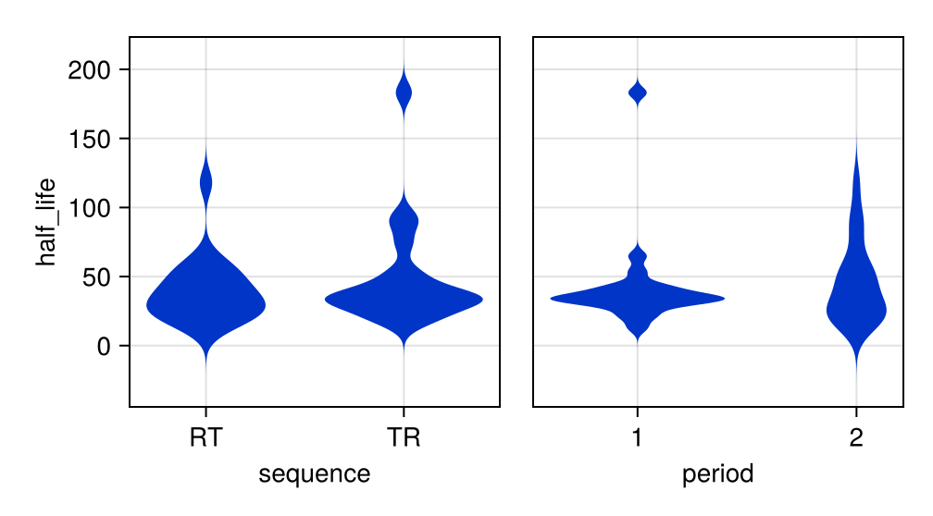
half_life vs. group

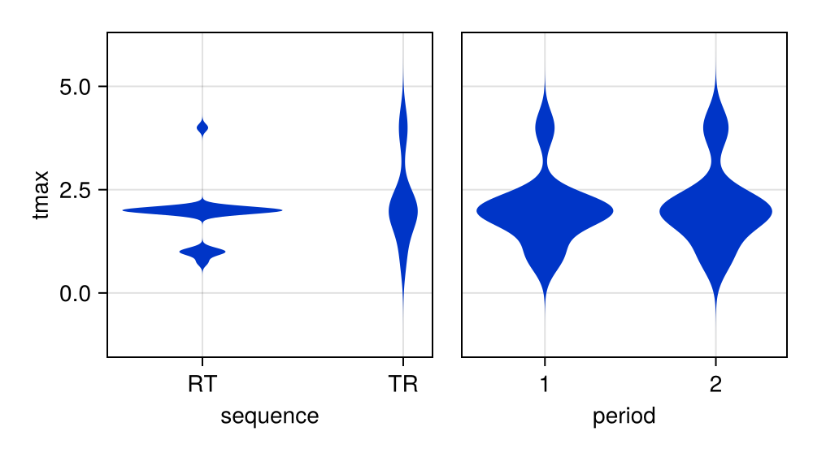
tmax vs. group

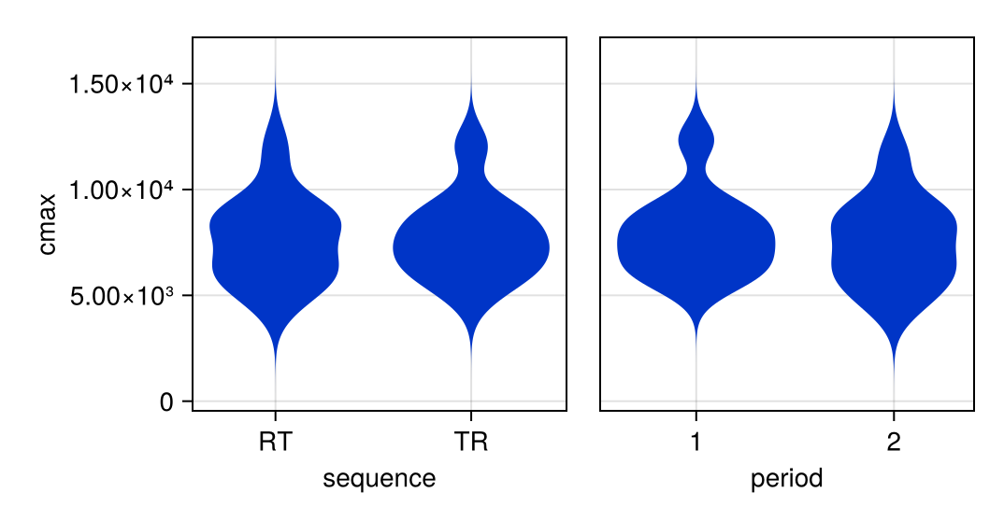
cmax vs. group

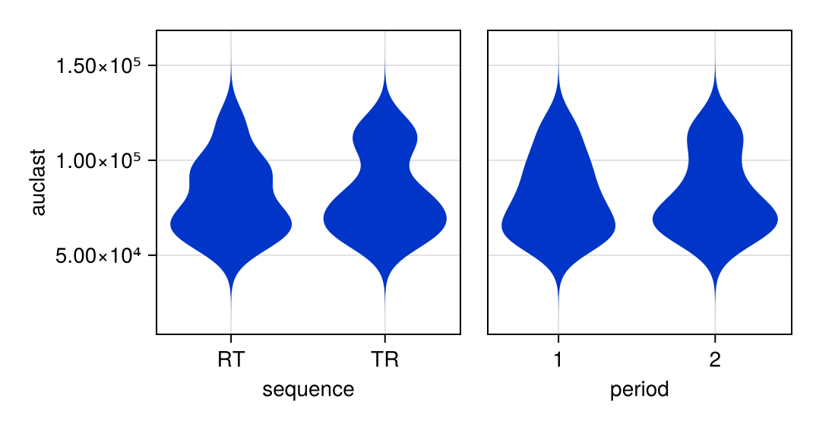
auclast vs. group

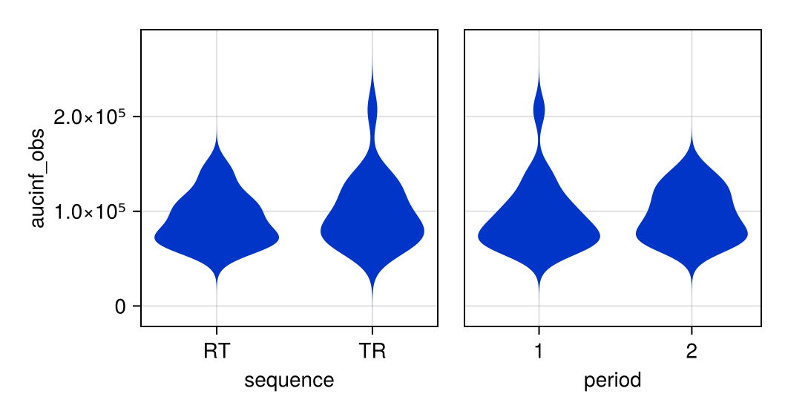
aucinf_obs vs. group

Output tables
BE GLM auclast
 | Coef. | Std. Error | t | Pr(>|t|) | Lower 95% | Upper 95%
(Intercept) | 11.3 | 0.0142 | 792 | <1e-41 | 11.2 | 11.3
sequence: TR | 0.0271 | 0.0142 | 1.91 | 0.0728 | -0.00277 | 0.0569
formulation: T | -0.0138 | 0.0142 | -0.971 | 0.3443 | -0.0437 | 0.0161
period: 2 | 0.0209 | 0.0142 | 1.47 | 0.1582 | -0.00893 | 0.0508
sequence: RT & id_within_sequence: 2 | -0.277 | 0.0301 | -9.18 | <1e-07 | -0.34 | -0.213
sequence: TR & id_within_sequence: 2 | -0.0317 | 0.0301 | -1.05 | 0.3063 | -0.0951 | 0.0316
sequence: RT & id_within_sequence: 3 | 0.184 | 0.0301 | 6.1 | <1e-05 | 0.121 | 0.247
sequence: TR & id_within_sequence: 3 | 0.374 | 0.0301 | 12.4 | <1e-09 | 0.311 | 0.438
sequence: RT & id_within_sequence: 4 | -0.00567 | 0.0301 | -0.188 | 0.8530 | -0.069 | 0.0577
sequence: TR & id_within_sequence: 4 | -0.223 | 0.0301 | -7.4 | <1e-06 | -0.286 | -0.16
sequence: RT & id_within_sequence: 5 | -0.186 | 0.0301 | -6.16 | <1e-05 | -0.249 | -0.122
sequence: TR & id_within_sequence: 5 | -0.261 | 0.0301 | -8.67 | <1e-07 | -0.325 | -0.198
sequence: RT & id_within_sequence: 6 | -0.097 | 0.0301 | -3.22 | 0.0048 | -0.16 | -0.0337
sequence: TR & id_within_sequence: 6 | 0.0263 | 0.0301 | 0.872 | 0.3946 | -0.037 | 0.0896
sequence: RT & id_within_sequence: 7 | -0.328 | 0.0301 | -10.9 | <1e-08 | -0.391 | -0.265
sequence: TR & id_within_sequence: 7 | 0.282 | 0.0301 | 9.35 | <1e-07 | 0.219 | 0.345
sequence: RT & id_within_sequence: 8 | 0.192 | 0.0301 | 6.38 | <1e-05 | 0.129 | 0.256
sequence: TR & id_within_sequence: 8 | -0.206 | 0.0301 | -6.84 | <1e-05 | -0.27 | -0.143
sequence: RT & id_within_sequence: 9 | -0.132 | 0.0301 | -4.38 | 0.0004 | -0.195 | -0.0688
sequence: TR & id_within_sequence: 9 | -0.259 | 0.0301 | -8.58 | <1e-07 | -0.322 | -0.195
sequence: RT & id_within_sequence: 10 | 0.425 | 0.0301 | 14.1 | <1e-10 | 0.361 | 0.488
sequence: TR & id_within_sequence: 10 | 0.328 | 0.0301 | 10.9 | <1e-08 | 0.264 | 0.391

BE Result cmax
Paradigm: Non replicated crossover design
Model: Linear model
Criteria: Standard ABE
Endpoint: cmax
Formulations: Reference(R), Test(T)
 |  | Results(cmax) | Assessment | Criteria
R | Geometric Marginal Mean | 7600
 | Geometric Naive Mean | 7600
T | Geometric Marginal Mean | 7325
 | Geometric Naive Mean | 7325
 | Geometric Mean T/R Ratio (%) | 96.38
 | Degrees of Freedom | 18
 | 90% Confidence Interval (%) | [92.74, 100.2] | Pass | CI ⊆ [80, 125]
Variability | CV (%) | σ̂ | 7.03 | 0.0702
ANOVA | Formulation (p-value) | 0.1142
 | Sequence (p-value) | 0.364
 | Period (p-value) | 0.02154

NCA parameter listing
 |  |  | Parameter
sequence | period | id | tmax | cmax | auclast | half_life | aucinf_obs
RT | 1 | 1 | 2 | 8390 | 92935 | 35.4 | 103775
RT | 1 | 2 | 2 | 8790 | 94828 | 33.3 | 106139
RT | 1 | 3 | 2 | 6495 | 76207 | 23 | 81593
RT | 1 | 4 | 2 | 5288 | 64092 | 30.6 | 68455
RT | 1 | 5 | 2 | 8814 | 73547 | 64.8 | 86616
RT | 1 | 6 | 1 | 6672 | 55663 | 43.3 | 60543
RT | 1 | 7 | 2 | 9337 | 96715 | 37.8 | 108778
RT | 1 | 8 | 2 | 5928 | 67644 | 13 | 69962
RT | 1 | 9 | 1 | 12401 | 118583 | 41.4 | 140016
RT | 1 | 10 | 0.75 | 7495 | 59525 | 53.5 | 67214
 |  | N | 10 | 10 | 10 | 10 | 10
 |  | GeoMean | 1.58 | 7735 | 77812 | 34.7 | 86372
 |  | GeoCV% | 40.4 | 25.5 | 24.9 | 47.4 | 27.4
RT | 2 | 1 | 2 | 8936 | 102763 | 57.5 | 124605
RT | 2 | 2 | 2 | 7895 | 92896 | 24.1 | 99925
RT | 2 | 3 | 1 | 5697 | 79118 | 13.5 | 83357
RT | 2 | 4 | 2 | 5187 | 65647 | 21.5 | 69662
RT | 2 | 5 | 2 | 8188 | 68286 | 118 | 94259
RT | 2 | 6 | 2 | 6215 | 56854 | 25 | 60643
RT | 2 | 7 | 1 | 8960 | 92616 | 52.5 | 115649
RT | 2 | 8 | 2 | 4373 | 69215 | 21.7 | 73805
RT | 2 | 9 | 4 | 11194 | 120221 | 47.3 | 146460
RT | 2 | 10 | 2 | 6513 | 58903 | 30.9 | 64052
 |  | N | 10 | 10 | 10 | 10 | 10
 |  | GeoMean | 1.87 | 7049 | 78369 | 33.8 | 89531
 |  | GeoCV% | 40.9 | 29.5 | 25.4 | 70.2 | 30.5
TR | 1 | 11 | 4 | 7103 | 80647 | 35.6 | 89156
TR | 1 | 12 | 2 | 5877 | 80231 | 35.5 | 88563
TR | 1 | 13 | 2 | 9401 | 117816 | 33.3 | 135210
TR | 1 | 14 | 2 | 8203 | 60652 | 43 | 66406
TR | 1 | 15 | 2 | 5719 | 61675 | 28.7 | 65806
TR | 1 | 16 | 2 | 12288 | 81229 | 32.6 | 87459
TR | 1 | 17 | 2 | 8042 | 100922 | 34.7 | 116926
TR | 1 | 18 | 1 | 6346 | 60164 | 20.7 | 63073
TR | 1 | 19 | 2 | 7239 | 60700 | 31.7 | 66300
TR | 1 | 20 | 4 | 7800 | 108855 | 183 | 207104
 |  | N | 10 | 10 | 10 | 10 | 10
 |  | GeoMean | 2.14 | 7610 | 78853 | 38.4 | 91541
 |  | GeoCV% | 40.9 | 23.2 | 26.2 | 63.2 | 40
TR | 2 | 11 | 2 | 6536 | 75316 | 94.3 | 105902
TR | 2 | 12 | 4 | 5579 | 75301 | 48.9 | 88968
TR | 2 | 13 | 2 | 8977 | 115553 | 35.2 | 138305
TR | 2 | 14 | 2 | 9068 | 67950 | 38.3 | 73955
TR | 2 | 15 | 4 | 4705 | 61886 | 17 | 65318
TR | 2 | 16 | 1 | 11846 | 83529 | 87.5 | 107866
TR | 2 | 17 | 2 | 8908 | 112090 | 25.4 | 127856
TR | 2 | 18 | 2 | 7166 | 70839 | 73.7 | 86115
TR | 2 | 19 | 0.75 | 6468 | 63201 | 53.4 | 71929
TR | 2 | 20 | 2 | 7889 | 113850 | 19.8 | 124907
 |  | N | 10 | 10 | 10 | 10 | 10
 |  | GeoMean | 1.94 | 7467 | 81639 | 42.3 | 96098
 |  | GeoCV% | 55.2 | 27.5 | 24.9 | 66.2 | 26.8

BE Result auclast
Paradigm: Non replicated crossover design
Model: Linear model
Criteria: Standard ABE
Endpoint: auclast
Formulations: Reference(R), Test(T)
 |  | Results(auclast) | Assessment | Criteria
R | Geometric Marginal Mean | 79703
 | Geometric Naive Mean | 79703
T | Geometric Marginal Mean | 78610
 | Geometric Naive Mean | 78610
 | Geometric Mean T/R Ratio (%) | 98.63
 | Degrees of Freedom | 18
 | 90% Confidence Interval (%) | [96.23, 101.1] | Pass | CI ⊆ [80, 125]
Variability | CV (%) | σ̂ | 4.5 | 0.0449
ANOVA | Formulation (p-value) | 0.3443
 | Sequence (p-value) | 0.07279
 | Period (p-value) | 0.1582

NCA parameter summary
 |  |  | Parameter
sequence | period |  | tmax | cmax | auclast | half_life | aucinf_obs
RT | 1 | N | 10 | 10 | 10 | 10 | 10
RT | 1 | GeoMean | 1.58 | 7735 | 77812 | 34.7 | 86372
RT | 1 | GeoCV% | 40.4 | 25.5 | 24.9 | 47.4 | 27.4
RT | 2 | N | 10 | 10 | 10 | 10 | 10
RT | 2 | GeoMean | 1.87 | 7049 | 78369 | 33.8 | 89531
RT | 2 | GeoCV% | 40.9 | 29.5 | 25.4 | 70.2 | 30.5
TR | 1 | N | 10 | 10 | 10 | 10 | 10
TR | 1 | GeoMean | 2.14 | 7610 | 78853 | 38.4 | 91541
TR | 1 | GeoCV% | 40.9 | 23.2 | 26.2 | 63.2 | 40
TR | 2 | N | 10 | 10 | 10 | 10 | 10
TR | 2 | GeoMean | 1.94 | 7467 | 81639 | 42.3 | 96098
TR | 2 | GeoCV% | 55.2 | 27.5 | 24.9 | 66.2 | 26.8

BE GLM cmax
 | Coef. | Std. Error | t | Pr(>|t|) | Lower 95% | Upper 95%
(Intercept) | 8.95 | 0.0222 | 403 | <1e-36 | 8.91 | 9
sequence: TR | 0.0207 | 0.0222 | 0.931 | 0.3640 | -0.026 | 0.0673
formulation: T | -0.0369 | 0.0222 | -1.66 | 0.1141 | -0.0835 | 0.00978
period: 2 | -0.0559 | 0.0222 | -2.52 | 0.0215 | -0.103 | -0.00924
sequence: RT & id_within_sequence: 2 | -0.0553 | 0.0471 | -1.17 | 0.2559 | -0.154 | 0.0437
sequence: TR & id_within_sequence: 2 | -0.275 | 0.0471 | -5.84 | <1e-04 | -0.374 | -0.176
sequence: RT & id_within_sequence: 3 | 0.121 | 0.0471 | 2.56 | 0.0197 | 0.0217 | 0.22
sequence: TR & id_within_sequence: 3 | 0.198 | 0.0471 | 4.2 | 0.0005 | 0.0987 | 0.297
sequence: RT & id_within_sequence: 4 | -0.194 | 0.0471 | -4.11 | 0.0007 | -0.293 | -0.0949
sequence: TR & id_within_sequence: 4 | 0.135 | 0.0471 | 2.86 | 0.0104 | 0.0357 | 0.234
sequence: RT & id_within_sequence: 5 | -0.344 | 0.0471 | -7.29 | <1e-06 | -0.443 | -0.245
sequence: TR & id_within_sequence: 5 | -0.374 | 0.0471 | -7.93 | <1e-06 | -0.473 | -0.275
sequence: RT & id_within_sequence: 6 | 0.14 | 0.0471 | 2.98 | 0.0081 | 0.0412 | 0.239
sequence: TR & id_within_sequence: 6 | 0.47 | 0.0471 | 9.98 | <1e-08 | 0.371 | 0.569
sequence: RT & id_within_sequence: 7 | -0.137 | 0.0471 | -2.91 | 0.0094 | -0.236 | -0.0379
sequence: TR & id_within_sequence: 7 | 0.116 | 0.0471 | 2.46 | 0.0243 | 0.0168 | 0.215
sequence: RT & id_within_sequence: 8 | 0.214 | 0.0471 | 4.54 | 0.0003 | 0.115 | 0.313
sequence: TR & id_within_sequence: 8 | -0.111 | 0.0471 | -2.37 | 0.0295 | -0.21 | -0.0125
sequence: RT & id_within_sequence: 9 | -0.372 | 0.0471 | -7.89 | <1e-06 | -0.471 | -0.273
sequence: TR & id_within_sequence: 9 | -0.0968 | 0.0471 | -2.06 | 0.0546 | -0.196 | 0.00214
sequence: RT & id_within_sequence: 10 | 0.467 | 0.0471 | 9.92 | <1e-07 | 0.368 | 0.566
sequence: TR & id_within_sequence: 10 | 0.0398 | 0.0471 | 0.844 | 0.4095 | -0.0592 | 0.139

BE Result tmax
Paradigm: Nonparametric analysis
Model: Signed rank test
Criteria: Standard ABE
Endpoint: tmax
Formulations: Reference(R), Test(T)
 |  | Results(tmax) | Assessment | Criteria
T | 90% Confidence Interval (%) | [100, 141.5] | Fail | CI ⊆ [80, 125]

BE GLM aucinf_obs
 | Coef. | Std. Error | t | Pr(>|t|) | Lower 95% | Upper 95%
(Intercept) | 11.4 | 0.0362 | 314 | <1e-34 | 11.3 | 11.4
sequence: TR | 0.0645 | 0.0362 | 1.78 | 0.0921 | -0.0117 | 0.141
formulation: T | -0.00633 | 0.0362 | -0.175 | 0.8632 | -0.0824 | 0.0698
period: 2 | 0.0423 | 0.0362 | 1.17 | 0.2587 | -0.0339 | 0.118
sequence: RT & id_within_sequence: 2 | -0.293 | 0.0769 | -3.81 | 0.0013 | -0.454 | -0.131
sequence: TR & id_within_sequence: 2 | -0.0551 | 0.0769 | -0.717 | 0.4827 | -0.217 | 0.106
sequence: RT & id_within_sequence: 3 | 0.158 | 0.0769 | 2.06 | 0.0547 | -0.00351 | 0.319
sequence: TR & id_within_sequence: 3 | 0.377 | 0.0769 | 4.91 | 0.0001 | 0.216 | 0.539
sequence: RT & id_within_sequence: 4 | -0.0642 | 0.0769 | -0.835 | 0.4146 | -0.226 | 0.0973
sequence: TR & id_within_sequence: 4 | -0.291 | 0.0769 | -3.79 | 0.0013 | -0.453 | -0.13
sequence: RT & id_within_sequence: 5 | -0.242 | 0.0769 | -3.14 | 0.0056 | -0.403 | -0.0802
sequence: TR & id_within_sequence: 5 | -0.358 | 0.0769 | -4.66 | 0.0002 | -0.52 | -0.197
sequence: RT & id_within_sequence: 6 | 0.0271 | 0.0769 | 0.353 | 0.7281 | -0.134 | 0.189
sequence: TR & id_within_sequence: 6 | 0.035 | 0.0769 | 0.455 | 0.6547 | -0.127 | 0.196
sequence: RT & id_within_sequence: 7 | -0.372 | 0.0769 | -4.85 | 0.0001 | -0.534 | -0.211
sequence: TR & id_within_sequence: 7 | 0.265 | 0.0769 | 3.45 | 0.0029 | 0.104 | 0.427
sequence: RT & id_within_sequence: 8 | 0.243 | 0.0769 | 3.17 | 0.0053 | 0.0818 | 0.405
sequence: TR & id_within_sequence: 8 | -0.241 | 0.0769 | -3.14 | 0.0057 | -0.403 | -0.0796
sequence: RT & id_within_sequence: 9 | -0.202 | 0.0769 | -2.63 | 0.0171 | -0.363 | -0.0405
sequence: TR & id_within_sequence: 9 | -0.306 | 0.0769 | -3.98 | 0.0009 | -0.468 | -0.145
sequence: RT & id_within_sequence: 10 | 0.488 | 0.0769 | 6.34 | <1e-05 | 0.326 | 0.649
sequence: TR & id_within_sequence: 10 | 0.539 | 0.0769 | 7.02 | <1e-05 | 0.378 | 0.701

BE Result aucinf_obs
Paradigm: Non replicated crossover design
Model: Linear model
Criteria: Standard ABE
Endpoint: aucinf_obs
Formulations: Reference(R), Test(T)
 |  | Results(aucinf_obs) | Assessment | Criteria
R | Geometric Marginal Mean | 91105
 | Geometric Naive Mean | 91105
T | Geometric Marginal Mean | 90530
 | Geometric Naive Mean | 90530
 | Geometric Mean T/R Ratio (%) | 99.37
 | Degrees of Freedom | 18
 | 90% Confidence Interval (%) | [93.32, 105.8] | Pass | CI ⊆ [80, 125]
Variability | CV (%) | σ̂ | 11.49 | 0.1146
ANOVA | Formulation (p-value) | 0.8632
 | Sequence (p-value) | 0.09213
 | Period (p-value) | 0.2587

Task: NCA + DP

Input plots
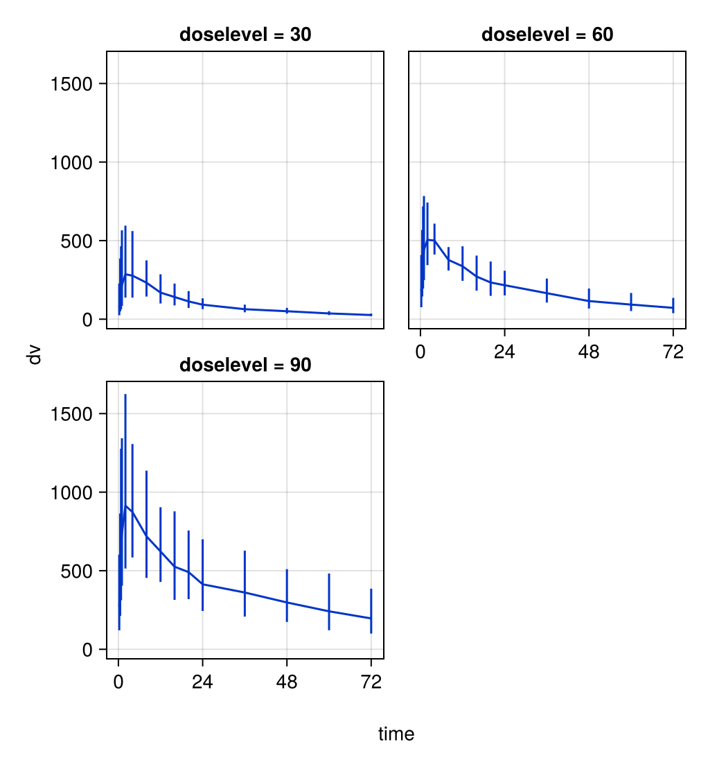
Summary Observations vs. Time

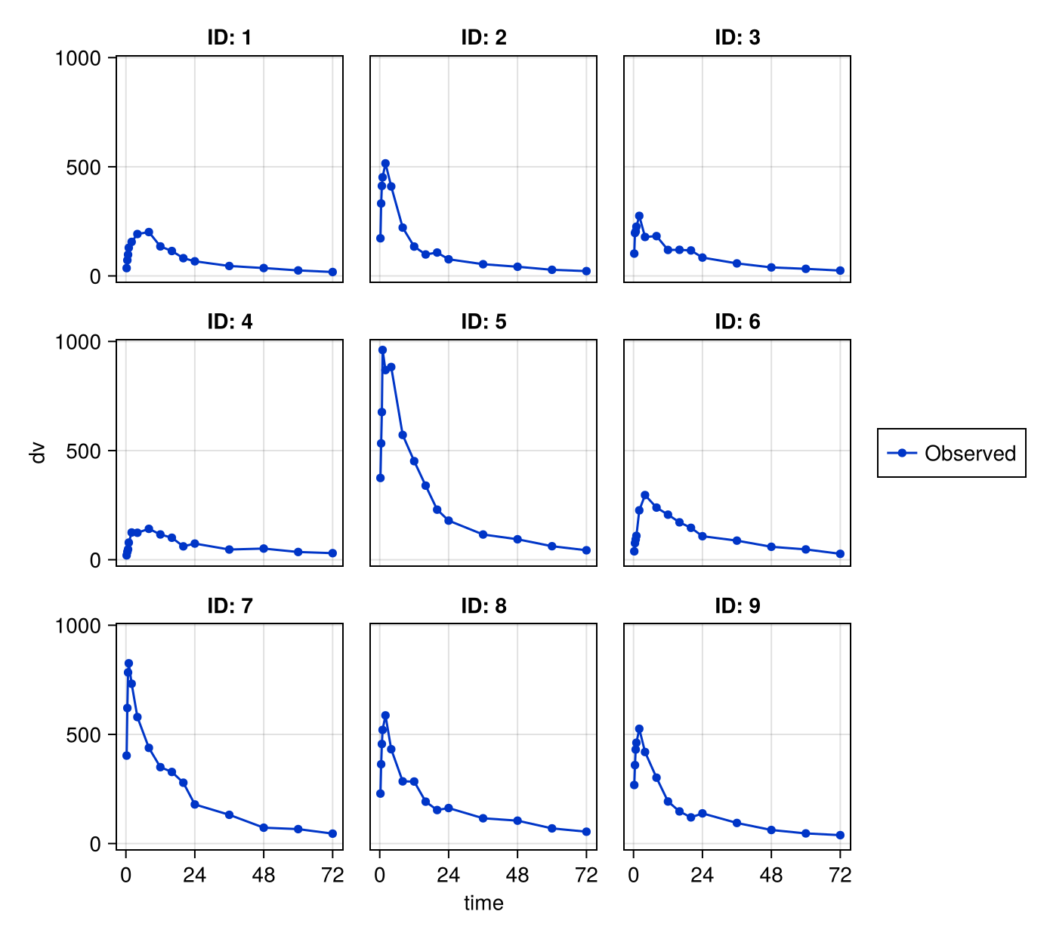
Observations vs. Time (1 of 2)

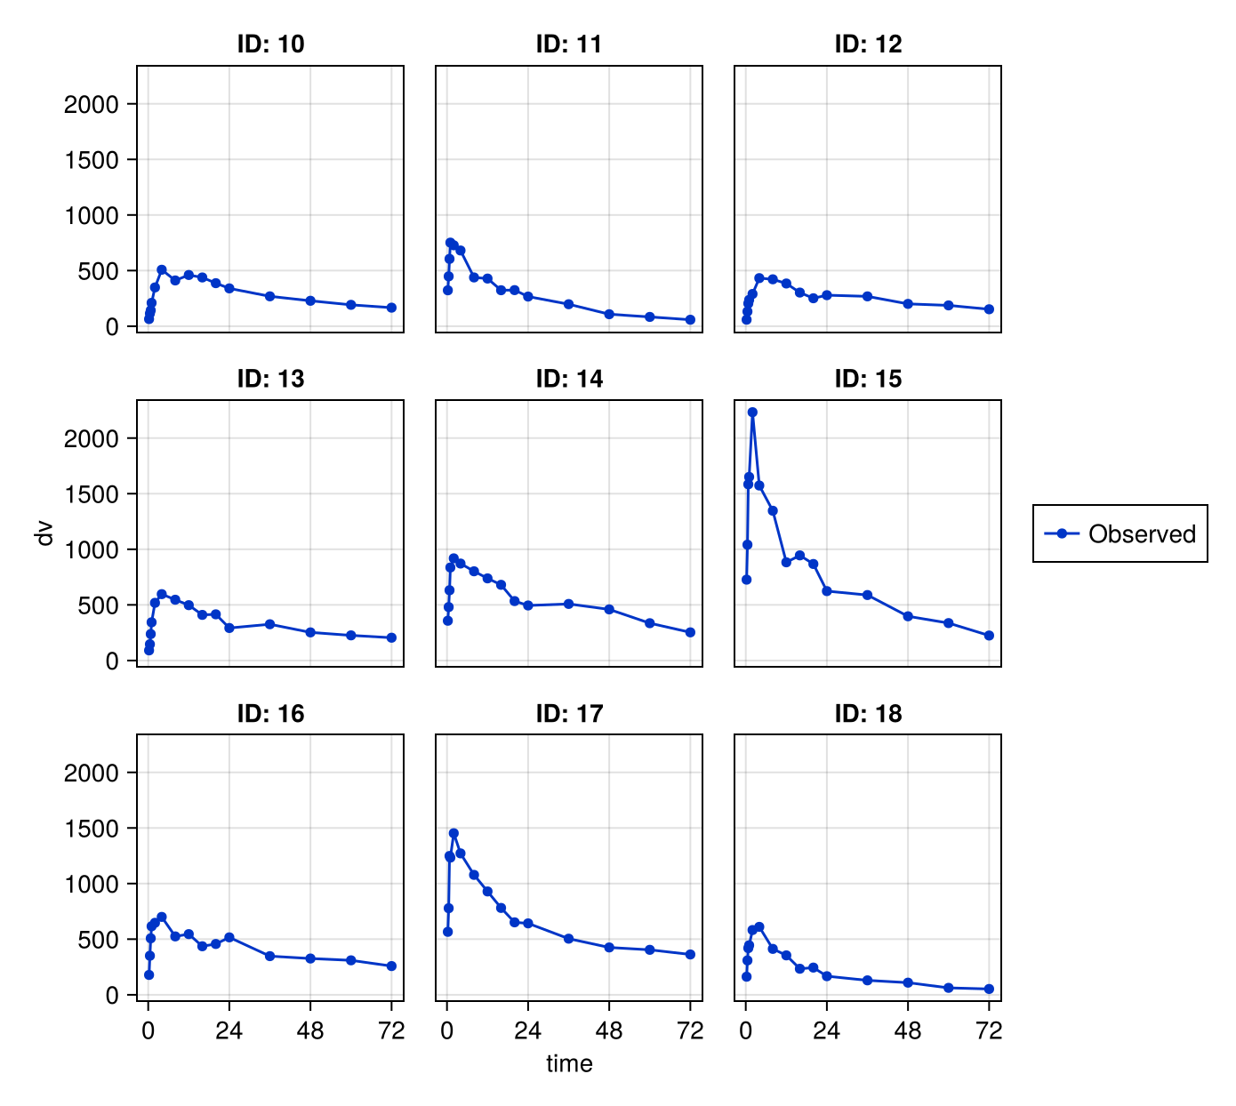
Observations vs. Time (2 of 2)

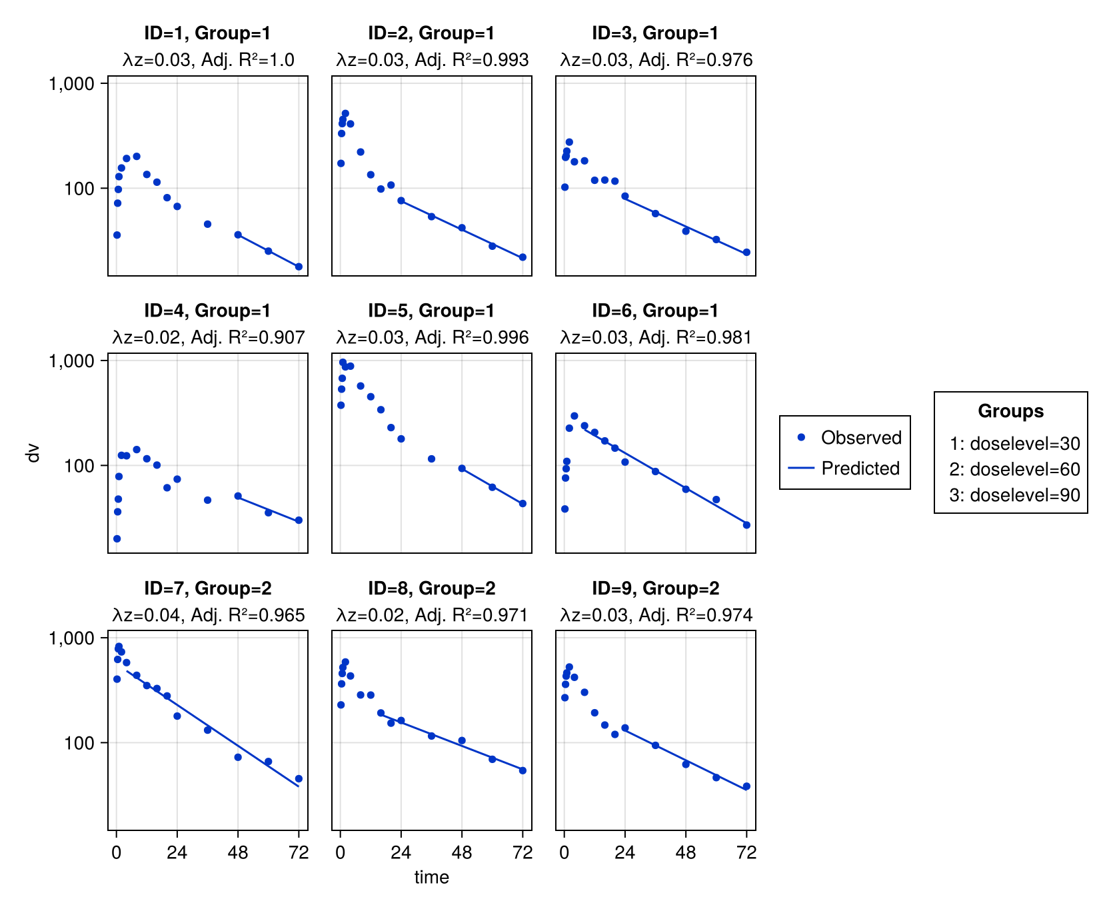
Subject Fits (1 of 2)

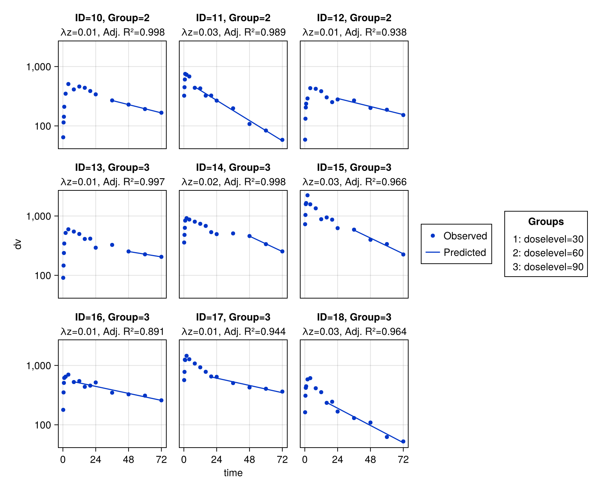
Subject Fits (2 of 2)

Input tables
Listing of concentrations at nominal time points
 |  | time
 |  | 0 | 0.25 | 0.5 | 0.75 | 1 | 2 | 4 | 8 | 12 | 16 | 20 | 24 | 36 | 48 | 60 | 72
doselevel | id | dv
30 | 1 | - | 35.8 | 72 | 97.3 | 129 | 156 | 192 | 201 | 135 | 114 | 81.2 | 67 | 45.4 | 36 | 25.1 | 17.9
30 | 2 | - | 172 | 332 | 412 | 452 | 516 | 410 | 221 | 134 | 98.2 | 107 | 76.2 | 53.6 | 42 | 28 | 22
30 | 3 | - | 102 | 197 | 203 | 225 | 275 | 178 | 182 | 119 | 120 | 117 | 84 | 57.3 | 38.9 | 32.4 | 24.5
30 | 4 | - | 20 | 36.2 | 47.7 | 78.4 | 125 | 124 | 142 | 116 | 101 | 61.3 | 74 | 46.7 | 51.1 | 35.4 | 30.1
30 | 5 | - | 375 | 533 | 676 | 961 | 869 | 883 | 572 | 452 | 339 | 229 | 179 | 115 | 93.7 | 61.9 | 43.3
30 | 6 | - | 38.4 | 75.9 | 93 | 109 | 226 | 296 | 239 | 206 | 171 | 146 | 108 | 87.5 | 59.3 | 47.3 | 27
 | N | 0 | 6 | 6 | 6 | 6 | 6 | 6 | 6 | 6 | 6 | 6 | 6 | 6 | 6 | 6 | 6
 | GeoMean | - | 75.2 | 138 | 170 | 218 | 286 | 277 | 232 | 169 | 141 | 113 | 92.1 | 63.5 | 50.5 | 36.5 | 26.4
 | GeoCV% | - | 155 | 137 | 131 | 121 | 84.5 | 80.2 | 50.6 | 56.3 | 50.3 | 48.5 | 37.6 | 39 | 36.5 | 34.7 | 30.8
 | Minimum | - | 20 | 36.2 | 47.7 | 78.4 | 125 | 124 | 142 | 116 | 98.2 | 61.3 | 67 | 45.4 | 36 | 25.1 | 17.9
 | Maximum | - | 375 | 533 | 676 | 961 | 869 | 883 | 572 | 452 | 339 | 229 | 179 | 115 | 93.7 | 61.9 | 43.3
60 | 7 | - | 403 | 621 | 784 | 826 | 732 | 579 | 438 | 350 | 328 | 279 | 179 | 132 | 72.6 | 66.1 | 45.4
60 | 8 | - | 229 | 363 | 456 | 521 | 587 | 432 | 285 | 284 | 192 | 153 | 163 | 116 | 105 | 69.4 | 54.2
60 | 9 | - | 268 | 359 | 431 | 462 | 526 | 419 | 302 | 193 | 147 | 120 | 138 | 94.2 | 62.1 | 46.4 | 38.4
60 | 10 | - | 64.3 | 114 | 143 | 210 | 349 | 508 | 411 | 461 | 438 | 387 | 340 | 269 | 229 | 192 | 167
60 | 11 | - | 323 | 448 | 605 | 752 | 727 | 681 | 438 | 428 | 323 | 324 | 267 | 198 | 108 | 83.5 | 58.2
60 | 12 | - | 58.6 | 132 | 204 | 237 | 290 | 432 | 422 | 384 | 303 | 251 | 279 | 268 | 201 | 187 | 152
 | N | 0 | 6 | 6 | 6 | 6 | 6 | 6 | 6 | 6 | 6 | 6 | 6 | 6 | 6 | 6 | 6
 | GeoMean | - | 176 | 286 | 374 | 442 | 505 | 500 | 377 | 336 | 271 | 233 | 216 | 165 | 115 | 92.8 | 72
 | GeoCV% | - | 101 | 77.4 | 72.9 | 62.5 | 39.9 | 19.7 | 19.9 | 33 | 41.7 | 47.6 | 36.7 | 47 | 56.6 | 63.9 | 70.2
 | Minimum | - | 58.6 | 114 | 143 | 210 | 290 | 419 | 285 | 193 | 147 | 120 | 138 | 94.2 | 62.1 | 46.4 | 38.4
 | Maximum | - | 403 | 621 | 784 | 826 | 732 | 681 | 438 | 461 | 438 | 387 | 340 | 269 | 229 | 192 | 167
90 | 13 | - | 90.8 | 146 | 238 | 344 | 518 | 597 | 546 | 497 | 410 | 415 | 292 | 326 | 253 | 226 | 205
90 | 14 | - | 357 | 480 | 632 | 836 | 918 | 872 | 802 | 738 | 680 | 534 | 495 | 509 | 459 | 335 | 253
90 | 15 | - | 727 | 1041 | 1584 | 1650 | 2232 | 1573 | 1346 | 883 | 945 | 868 | 624 | 589 | 397 | 336 | 225
90 | 16 | - | 178 | 351 | 508 | 616 | 647 | 700 | 525 | 545 | 436 | 457 | 516 | 347 | 326 | 310 | 258
90 | 17 | - | 566 | 778 | 1248 | 1234 | 1453 | 1271 | 1078 | 929 | 781 | 651 | 642 | 504 | 426 | 404 | 363
90 | 18 | - | 162 | 309 | 420 | 445 | 582 | 611 | 413 | 354 | 234 | 245 | 167 | 130 | 109 | 62.3 | 52.4
 | N | 0 | 6 | 6 | 6 | 6 | 6 | 6 | 6 | 6 | 6 | 6 | 6 | 6 | 6 | 6 | 6
 | GeoMean | - | 270 | 428 | 631 | 737 | 914 | 874 | 719 | 623 | 525 | 491 | 413 | 361 | 298 | 242 | 196
 | GeoCV% | - | 95.1 | 79.8 | 80.1 | 65.8 | 62.7 | 41.9 | 48.4 | 38.7 | 54.9 | 45.2 | 56.5 | 59.7 | 57.9 | 78.2 | 76
 | Minimum | - | 90.8 | 146 | 238 | 344 | 518 | 597 | 413 | 354 | 234 | 245 | 167 | 130 | 109 | 62.3 | 52.4
 | Maximum | - | 727 | 1041 | 1584 | 1650 | 2232 | 1573 | 1346 | 929 | 945 | 868 | 642 | 589 | 459 | 404 | 363
- No value

Summary of concentrations at nominal time points
 |  | time
 |  | 0 | 0.25 | 0.5 | 0.75 | 1 | 2 | 4 | 8 | 12 | 16 | 20 | 24 | 36 | 48 | 60 | 72
doselevel |  | dv
30 | N | 0 | 6 | 6 | 6 | 6 | 6 | 6 | 6 | 6 | 6 | 6 | 6 | 6 | 6 | 6 | 6
30 | GeoMean | - | 75.2 | 138 | 170 | 218 | 286 | 277 | 232 | 169 | 141 | 113 | 92.1 | 63.5 | 50.5 | 36.5 | 26.4
30 | GeoCV% | - | 155 | 137 | 131 | 121 | 84.5 | 80.2 | 50.6 | 56.3 | 50.3 | 48.5 | 37.6 | 39 | 36.5 | 34.7 | 30.8
30 | Minimum | - | 20 | 36.2 | 47.7 | 78.4 | 125 | 124 | 142 | 116 | 98.2 | 61.3 | 67 | 45.4 | 36 | 25.1 | 17.9
30 | Maximum | - | 375 | 533 | 676 | 961 | 869 | 883 | 572 | 452 | 339 | 229 | 179 | 115 | 93.7 | 61.9 | 43.3
60 | N | 0 | 6 | 6 | 6 | 6 | 6 | 6 | 6 | 6 | 6 | 6 | 6 | 6 | 6 | 6 | 6
60 | GeoMean | - | 176 | 286 | 374 | 442 | 505 | 500 | 377 | 336 | 271 | 233 | 216 | 165 | 115 | 92.8 | 72
60 | GeoCV% | - | 101 | 77.4 | 72.9 | 62.5 | 39.9 | 19.7 | 19.9 | 33 | 41.7 | 47.6 | 36.7 | 47 | 56.6 | 63.9 | 70.2
60 | Minimum | - | 58.6 | 114 | 143 | 210 | 290 | 419 | 285 | 193 | 147 | 120 | 138 | 94.2 | 62.1 | 46.4 | 38.4
60 | Maximum | - | 403 | 621 | 784 | 826 | 732 | 681 | 438 | 461 | 438 | 387 | 340 | 269 | 229 | 192 | 167
90 | N | 0 | 6 | 6 | 6 | 6 | 6 | 6 | 6 | 6 | 6 | 6 | 6 | 6 | 6 | 6 | 6
90 | GeoMean | - | 270 | 428 | 631 | 737 | 914 | 874 | 719 | 623 | 525 | 491 | 413 | 361 | 298 | 242 | 196
90 | GeoCV% | - | 95.1 | 79.8 | 80.1 | 65.8 | 62.7 | 41.9 | 48.4 | 38.7 | 54.9 | 45.2 | 56.5 | 59.7 | 57.9 | 78.2 | 76
90 | Minimum | - | 90.8 | 146 | 238 | 344 | 518 | 597 | 413 | 354 | 234 | 245 | 167 | 130 | 109 | 62.3 | 52.4
90 | Maximum | - | 727 | 1041 | 1584 | 1650 | 2232 | 1573 | 1346 | 929 | 945 | 868 | 642 | 589 | 459 | 404 | 363
- No value

Per-subject data
 |  | doselevel
 | Total | 30 | 60 | 90
rate
Mean (SD) | 0 (0) | 0 (0) | 0 (0) | 0 (0)
Median [Min, Max] | 0 [0, 0] | 0 [0, 0] | 0 [0, 0] | 0 [0, 0]
age
Mean (SD) | 36.6 (13) | 37 (13) | 38.5 (14.9) | 34.3 (13.1)
Median [Min, Max] | 37.5 [20, 55] | 35.5 [24, 52] | 40 [20, 55] | 34 [21, 49]
wt
Mean (SD) | 80.2 (29) | 69 (29.1) | 90 (25.3) | 81.5 (33.4)
Median [Min, Max] | 72 [30, 120] | 67.5 [30, 119] | 88.5 [62, 118] | 77 [33, 120]
isPM
no | 12 (66.7%) | 6 (100%) | 4 (66.7%) | 2 (33.3%)
yes | 6 (33.3%) | 0 (0%) | 2 (33.3%) | 4 (66.7%)
isfed
no | 12 (66.7%) | 3 (50%) | 4 (66.7%) | 5 (83.3%)
yes | 6 (33.3%) | 3 (50%) | 2 (33.3%) | 1 (16.7%)
sex
female | 6 (33.3%) | 2 (33.3%) | 3 (50%) | 1 (16.7%)
male | 12 (66.7%) | 4 (66.7%) | 3 (50%) | 5 (83.3%)
route
ev | 18 (100%) | 6 (100%) | 6 (100%) | 6 (100%)

Output plots
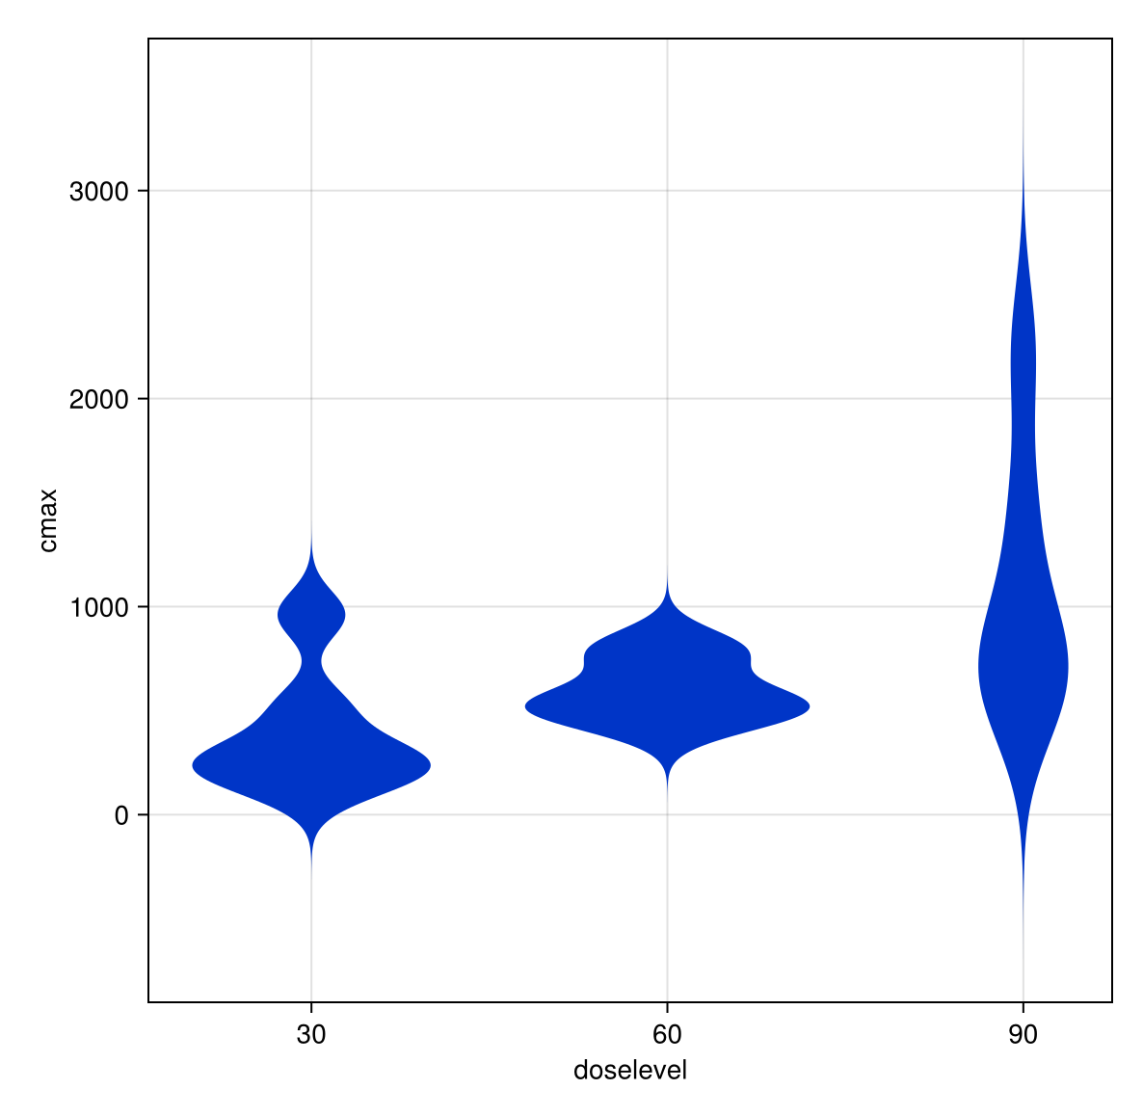
cmax vs. group

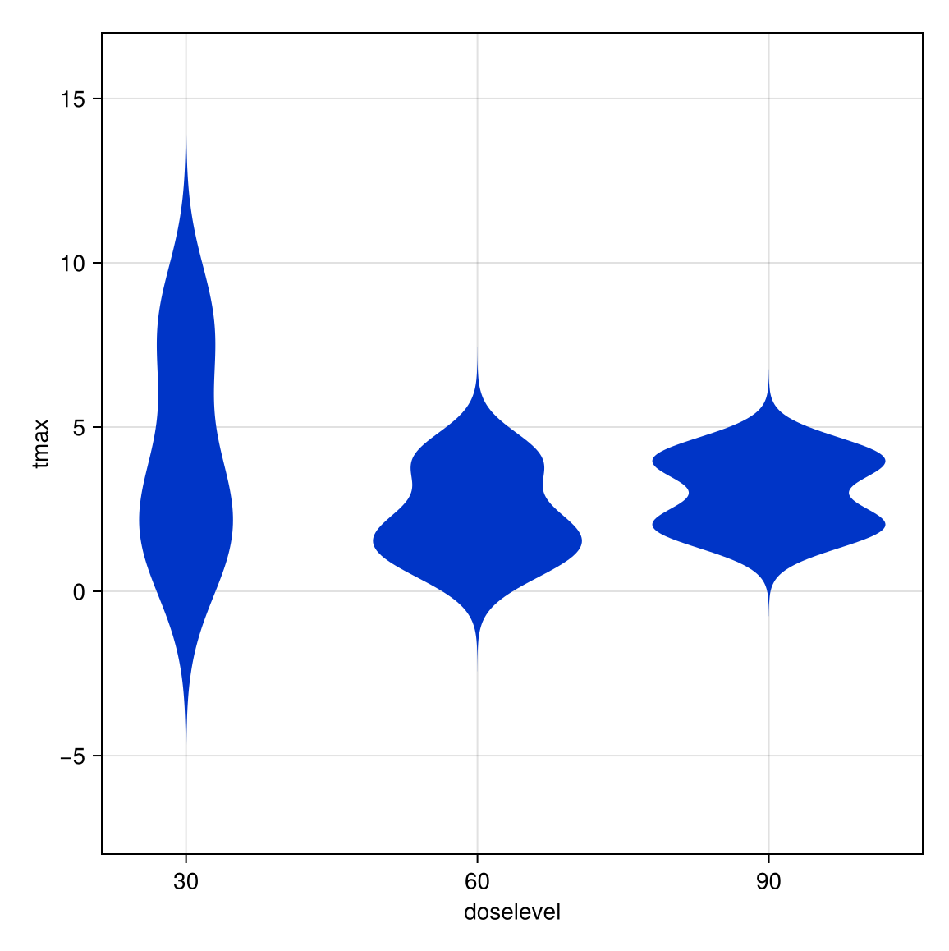
tmax vs. group

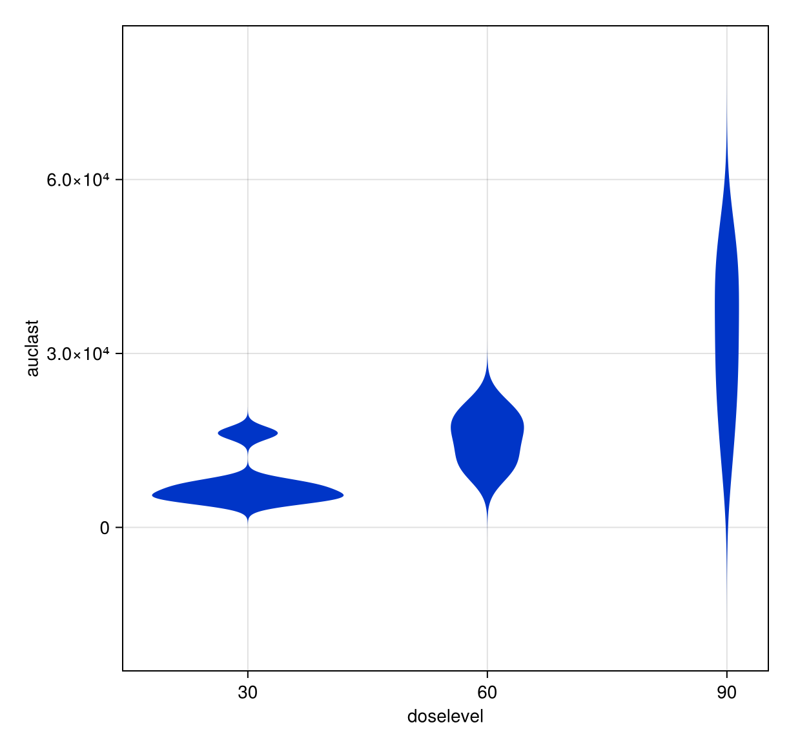
auclast vs. group

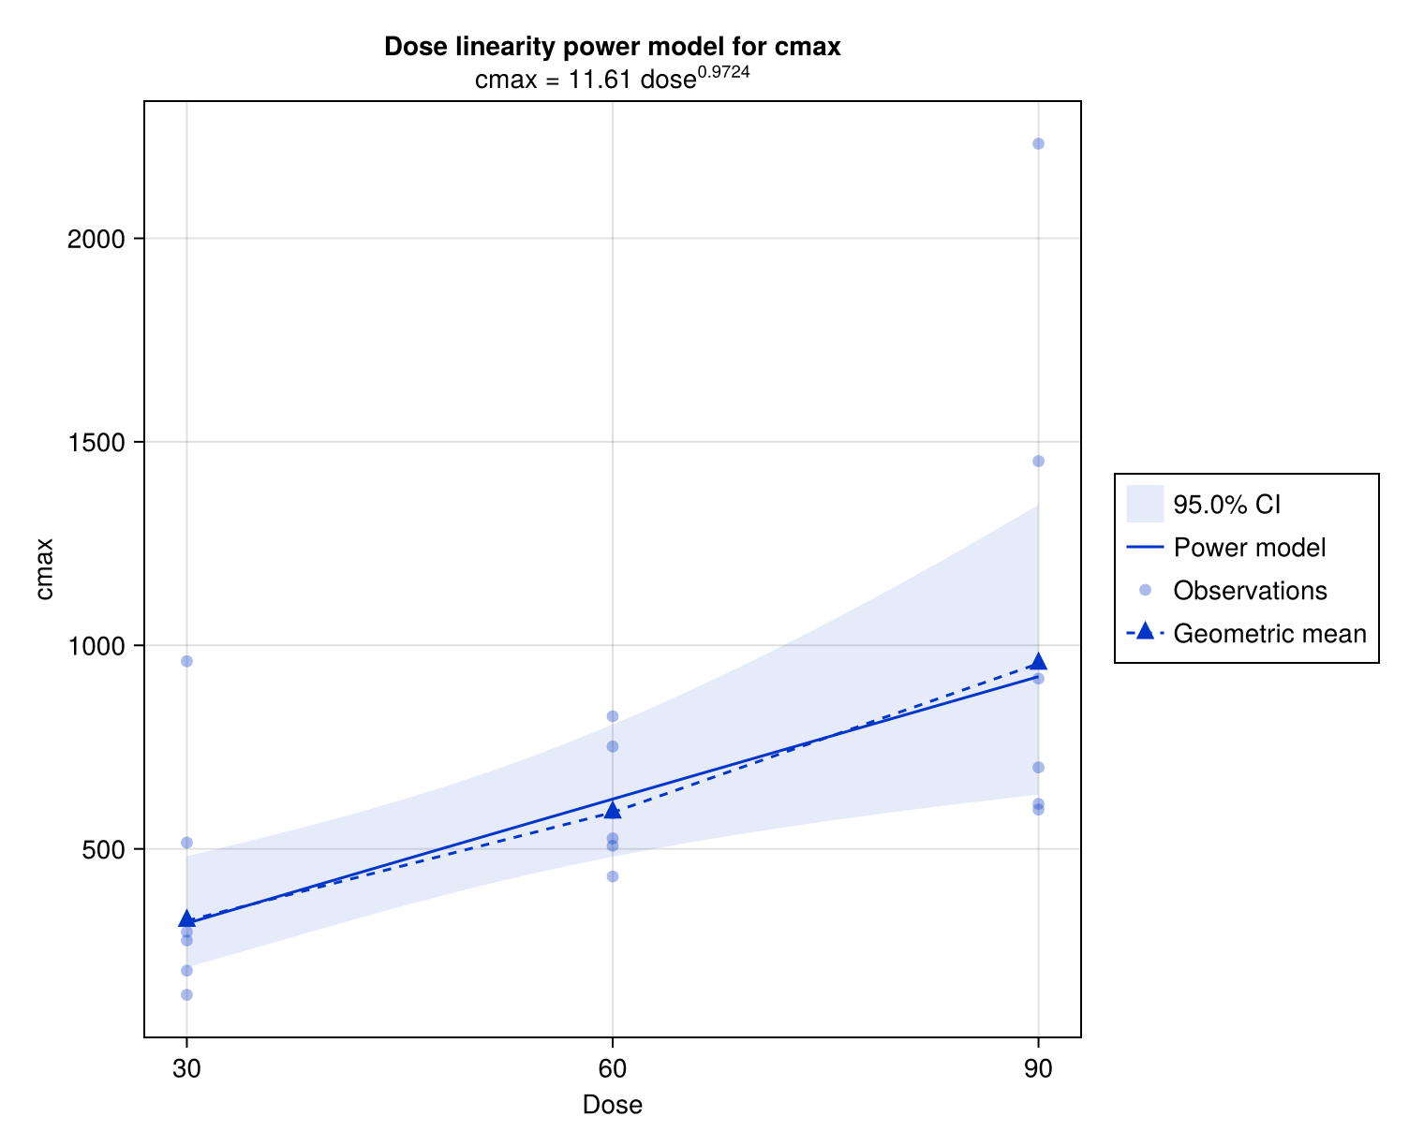
Dose Linearity Power Model cmax

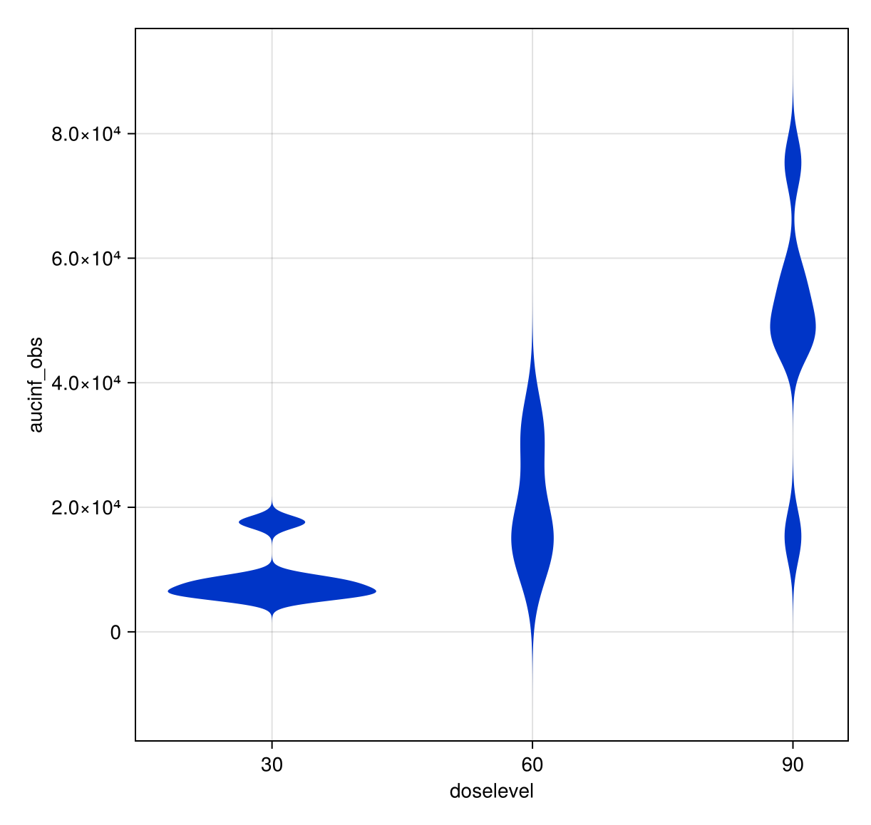
aucinf_obs vs. group

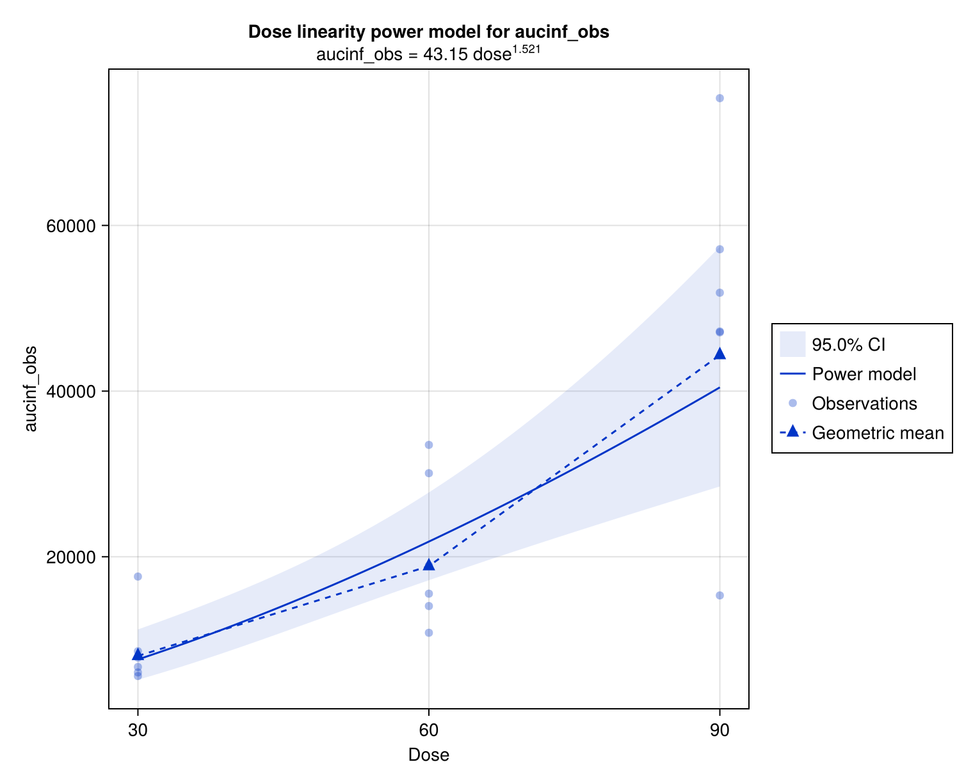
Dose Linearity Power Model aucinf_obs

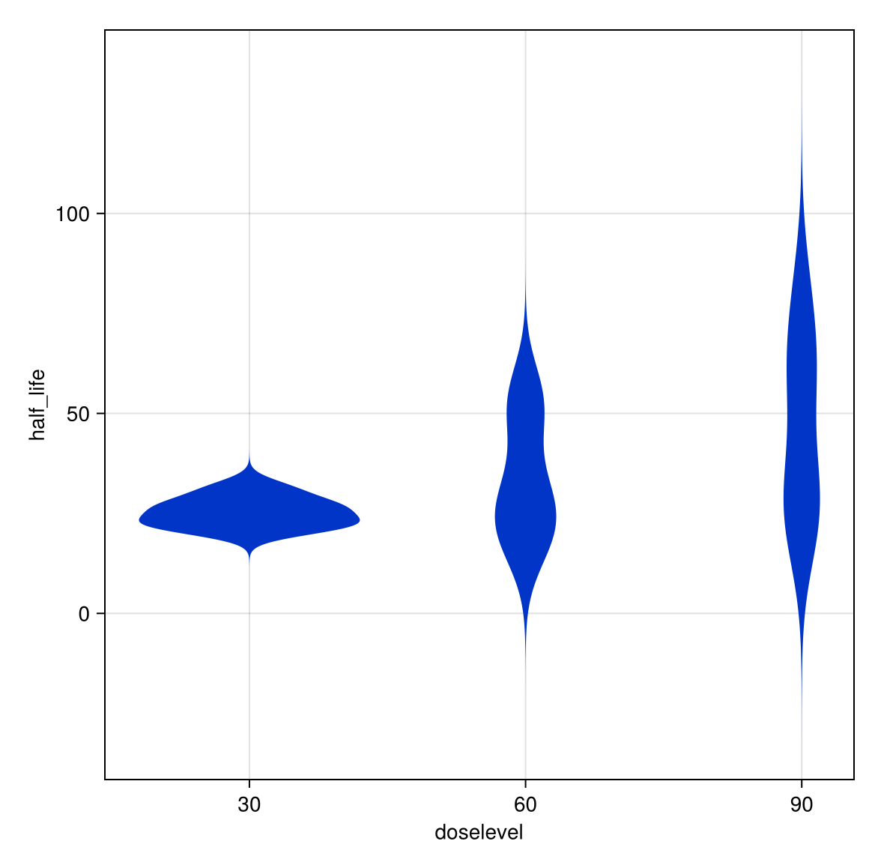
half_life vs. group

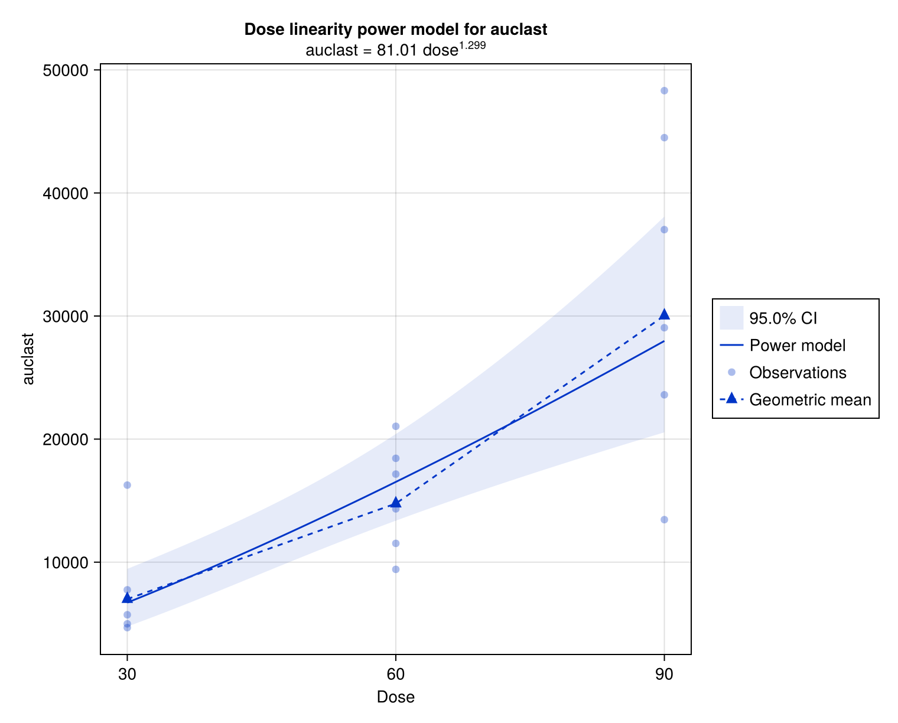
Dose Linearity Power Model auclast

Output tables
NCA parameter summary
 |  | Parameter
doselevel |  | tmax | cmax | auclast | half_life | aucinf_obs
30 | N | 6 | 6 | 6 | 6 | 6
30 | GeoMean | 3.17 | 324 | 7000 | 25.1 | 8031
30 | GeoCV% | 101 | 77.4 | 48 | 14.8 | 43.5
60 | N | 6 | 6 | 6 | 6 | 6
60 | GeoMean | 2 | 590 | 14762 | 31 | 18870
60 | GeoCV% | 68.5 | 25 | 31.1 | 47.1 | 46.5
90 | N | 6 | 6 | 6 | 6 | 6
90 | GeoMean | 2.83 | 955 | 30035 | 41.9 | 44354
90 | GeoCV% | 39.4 | 57.2 | 50.3 | 54.4 | 59.3

Dose Linearity Ratio Test cmax
 | Ratio | Estimate | low CI 95% | high CI 95%
60.0 vs. 30.0 | 2 | 1.82 | 0.94 | 3.53
90.0 vs. 30.0 | 3 | 2.95 | 1.34 | 6.5

Dose Linearity Power Model auclast
 | Coefficient | Lower 95% | Upper 95%
α | 81 | 12.9 | 508
β | 1.3 | 0.843 | 1.76

Dose Linearity Power Model cmax
 | Coefficient | Lower 95% | Upper 95%
α | 11.6 | 1.23 | 109
β | 0.972 | 0.415 | 1.53

NCA parameter listing
 |  | Parameter
doselevel | id | tmax | cmax | auclast | half_life | aucinf_obs
30 | 1 | 8 | 201 | 4988 | 23.8 | 5601
30 | 2 | 2 | 516 | 6982 | 26.6 | 7825
30 | 3 | 2 | 275 | 5727 | 27.4 | 6696
30 | 4 | 8 | 142 | 4681 | 31.3 | 6039
30 | 5 | 1 | 961 | 16262 | 21.6 | 17611
30 | 6 | 4 | 296 | 7751 | 21.6 | 8593
 | N | 6 | 6 | 6 | 6 | 6
 | GeoMean | 3.17 | 324 | 7000 | 25.1 | 8031
 | GeoCV% | 101 | 77.4 | 48 | 14.8 | 43.5
60 | 7 | 1 | 826 | 14332 | 18.5 | 15546
60 | 8 | 2 | 587 | 11526 | 32.3 | 14052
60 | 9 | 2 | 526 | 9414 | 25.4 | 10825
60 | 10 | 4 | 508 | 21040 | 51.8 | 33506
60 | 11 | 1 | 752 | 17156 | 21.2 | 18935
60 | 12 | 4 | 432 | 18438 | 53 | 30090
 | N | 6 | 6 | 6 | 6 | 6
 | GeoMean | 2 | 590 | 14762 | 31 | 18870
 | GeoCV% | 68.5 | 25 | 31.1 | 47.1 | 46.5
90 | 13 | 4 | 597 | 23600 | 79.5 | 47094
90 | 14 | 2 | 918 | 37021 | 27.9 | 47202
90 | 15 | 2 | 2232 | 48314 | 27.2 | 57126
90 | 16 | 4 | 700 | 29050 | 61.3 | 51880
90 | 17 | 2 | 1453 | 44495 | 59 | 75366
90 | 18 | 4 | 611 | 13455 | 24.9 | 15333
 | N | 6 | 6 | 6 | 6 | 6
 | GeoMean | 2.83 | 955 | 30035 | 41.9 | 44354
 | GeoCV% | 39.4 | 57.2 | 50.3 | 54.4 | 59.3

System Information
System information
Operating system | Linux (x86_64-linux-gnu)
CPU | Intel(R) Xeon(R) Platinum 8375C CPU @ 2.90GHz
Memory | 58.3427734375 GB
Word size | 64
Julia version | 1.10.10
PumasCP Version | 3.7.0

